Edmond Seal Gauthreaux
1876 – April 16, 1956

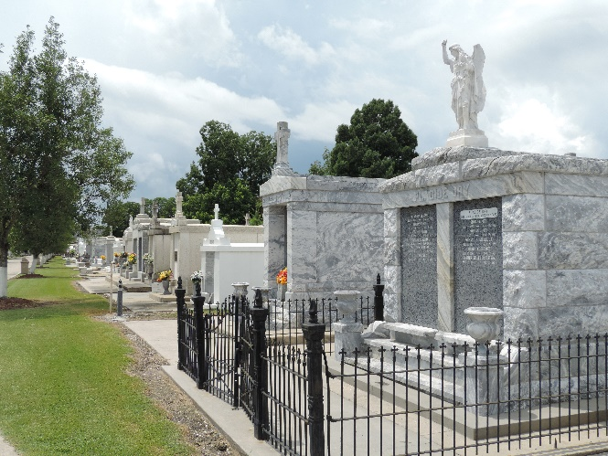

GAUTHREAUX – In St. Rose, La., on Monday, April 16, 1956, at 10:25 o’clock a.m., Edmond Seal Gauthreaux, beloved husband of Justine Marchand; father of Mrs. Martin Cambre of Laplace, La., Lester, Nolan, Clarence Gauthreaux, all of St. Rose, La., Arthur Gauthreaux of Arabi, La.; aged 80 years; a native of Donaldsonville, La., and a resident of St. Rose, La., for the past 30 years.
Relatives and friends of the family are invited to attend the funeral which will take place from the Alexander funeral home, Norco, La., on Tuesday, April 17, 1956, at 9:30 o’clock a.m. Religious services at St. Charles Borromeo church, Destrehan, La. Interment in St. Peter cemetery, Reserve, La.
The Times-Picayune, New Orleans, Louisiana
Tuesday, April 17, 1956, p. 2

