Justine Aglae (Marchand) Gauthreaux
1883 – March 28, 1962

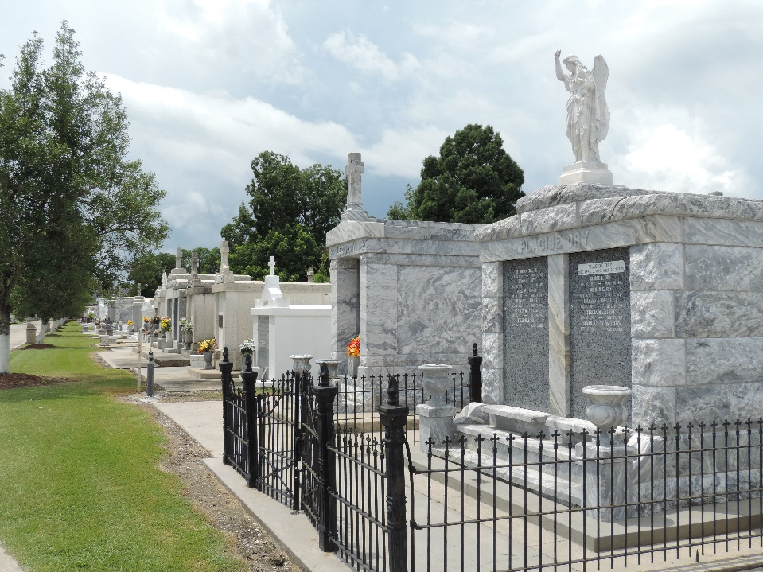

Widow of Edmond Gauthreaux
Mother of Mrs. Elma Cambre of LaPlace, La; Arthur Gauthreaux of Arabi, La; Lester, Clarence and Nolan Gauthreaux, all of St. Rose, La; and the late Mrs. Clothilde Madere.
Daughter of the late Aglae Lanoux and Thomas Marchand. Resident of St. Rose for 41 years
Extracted from The Times-Picayune, New Orleans, Louisiana
Thursday, March 28, 1962, p. 2

