Theresa (LeBlanc) Gauthreaux

December 2, 1888 – January 30, 1980

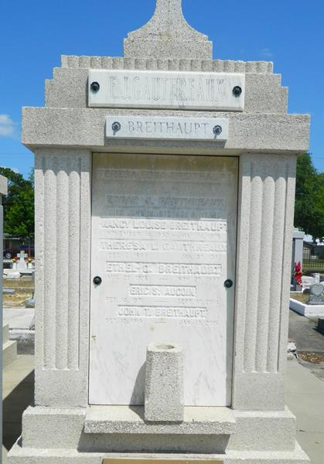

Theresa L. Gauthreaux, 91, a native of Lockport and a resident of Narco, La., died 7:30 a.m. Wednesday.  
 Survivors include three daughters, Mrs. Garland (Ruby) Tregre of Reserve, La., Mrs. S.P. (Tessie) Trosclair of Norco, La., Mrs. John (Tiny) Breithaupt of New Orleans; 11 grandchildren; and 20 great-grandchildren.  
 She is preceded in death by her husband, Edgard J. (Eddie) Gauthreaux; three sons, Eddie, Ervin and J.T. Gauthreaux.  
 The family prefers masses be offered. Visitation will be from 5 to 11 p.m. today at the Millett Funeral Home in LaPlace, LA., resuming 8 a.m. Friday and continuing until funeral time. The funeral will be 10 a.m. Friday with religious services following, 10:30 a.m., at St. Peter Catholic Church in Reserve, La. Burial will be in the church cemetery.

Millett Funeral Home in LaPlace, La., is handling arrangements.

Unknown source