Alex John Gautreau

July 9, 1937 – August 5, 2001

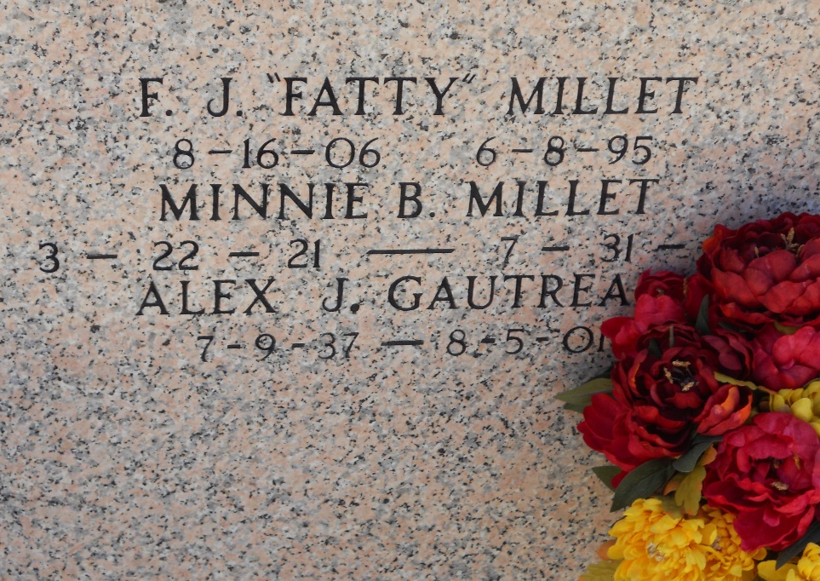

Photo by Team T-Lo

GARYVILLE - Alex John Gautreau, 64, a native of Gonzales and resident of Garyville, died Aug. 5.

He was the husband of Amelia Roussel Daigle Gautreau, father of Craig, Layne, Jeffrey, Chad and the late John Gautreau and stepfather of Michelle Kinler and Carl Daigle. He was the son of the late Dennis and Cecilia Decoteau Gautreau and brother of Lula Bell Brignac, Valburg Fife, Martha Perdue, Shirley Granier, Carolyn Wells and Vernon, Matthew and Dennis Gautreau Jr. He is survived by five grandchildren. He was a retired carpenter.

Services were Aug 7 at St. Hubert Catholic Church, Garyville, with interment at St. Peter Mausoleum, Reserve.

L'Observateur, LaPlace, Louisiana

August 8, 2001