Oliver Webby Gautreaux Jr
September 02, 1958 - October 18, 2023
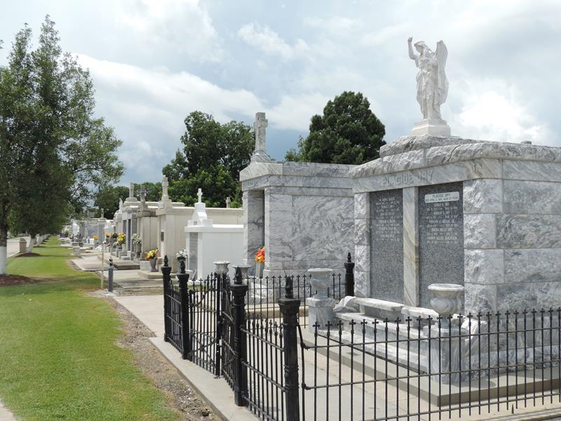

Webby Gautreaux, Jr. passed away on Wednesday, October 18, 2023 at the age of 65. He was born in Maui, HI and a resident of Reserve, LA.
Loving father of Hali Gautreaux and Heather Gautreaux Coburn (Matthew). Grandfather of Nicholas Holmes, III., Natalie Holmes, and Kade Coburn. Son of the late Carol Silva Gautreaux and Webby Gautreaux, Sr. Also survived by many friends, which were like his family, and his dog, Max.
Webby retired from Marathon after 15 years of service. Loved boating and fishing. He had a love for playing and collecting guitars. If it was anything related to LSU Webby had it.
Relatives and friends are invited to attend the Visitation and Funeral Mass at St. Peter Catholic Church, 1550 Hwy 44, Reserve on Tuesday, October 24, 2023. Visitation at the church from 9:00 a.m. to 11:00 a.m. with a Funeral Mass at 11:00 a.m. Interment in St. Peter Cemetery, Reserve, LA.

Rose Lynn Funeral Home, Lutcher, Louisiana
October 22, 2023

