Oliver W. Gautreaux Sr.
November 12, 1936 – October 29, 2013

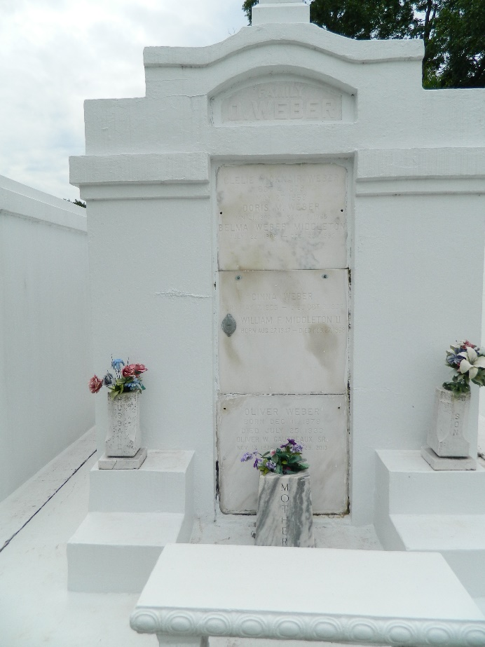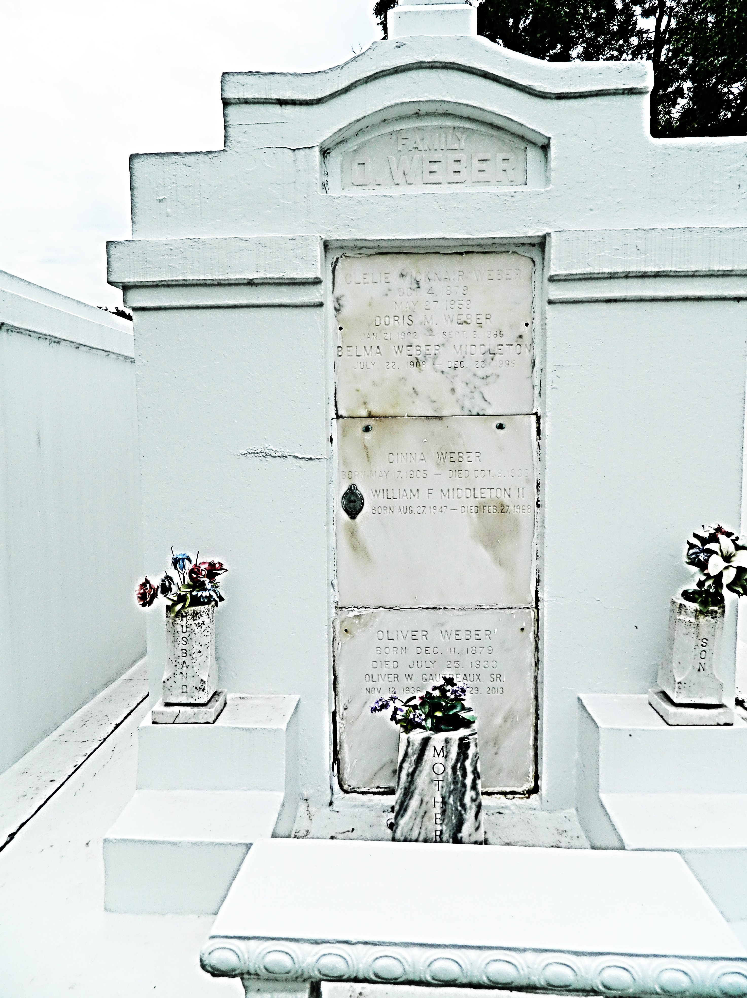

Oliver W. Gautreaux, 76, died Tuesday, Oct. 29, 2013.
He was the beloved husband of Catherine (Jerrie) Gautreaux, father of O. Webby Gautreaux Jr., grandfather of Hali Gautreaux and Heather Gautreaux, great-grandfather of Nicholas Holmes III and Natalie Holmes, son of the late George and Belma Weber Middleton and brother of George (Lamar) Gautreaux and the late W. F. Middleton II. He was an avid boater who enjoyed his weekends on Blind River and cooking with his many friends. He was a Navy veteran. He was a native and resident of Reserve. Relatives and friends are invited to attend services. Visitation will be held at Millet-Guidry Funeral Home, 2806 W. Airline Highway, LaPlace, on Saturday, Nov. 2, 2013, from 8 a.m. to 10:30 a.m., followed by Mass in the funeral home chapel at 10:30 a.m. Burial will follow in St. Peter Cemetery.
L'Observateur, La Place, Louisiana
Friday, November 1, 2013

