Angeline Marie (Madere) Gendron
September 11, 1987 March 22, 1958
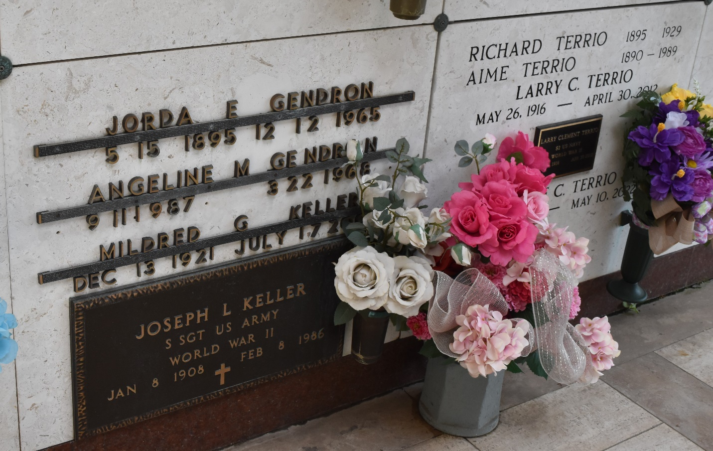

Angeline Madere from tree Haydel Family Tree
Birth 11 Sep 1897 St John the Baptist, Louisiana, USA
Residence 1940 St John the Baptist, Louisiana, USA
Death 22 Mar 1968 Louisiana, USA
Father Francois D'Assisi Madere (1866-1942)
Mother Felicie Duhe (1869-1949)
Spouse Jorda Gendron (1895-1965)
50198 People 2 Records 4 Sources

