Annabelle (Edler) Gendron
November 22, 1930 – September 11, 2003

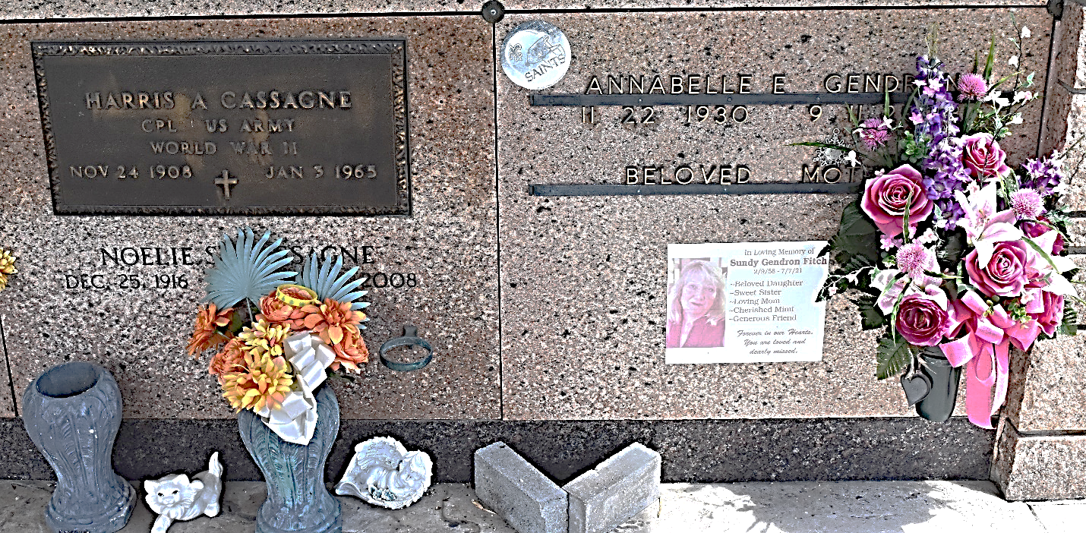
Photo by Team T-Lo

Annabelle Edler Gendron on Thursday, September 11, 2003 at 3:45 PM.
Beloved wife Dowie Gendron. Mother of Dowie (Dee) II, and David Gendron, Sandra Ratcliff, Anne Iris Terrio, Nancy Holmes, Geraldine Cox, Glenda Arcuri and Sundy Fitch. Daughter of the late Louis and Lillian Edler. Sister of Jean Martin and the late Roy Edler and Lorraine Madere. Also survived by 14 grandchildren and 2 great grandchildren. Age 72 years. A native and resident of LaPlace, LA.
Relatives and friends of the family, also employees of St. John the Baptist Parish School System are invited to attend services. Visitation at Millet-Guidry Funeral Home, 2806 W. Airline Hwy., LaPlace, LA. on Friday, September 12, 2003 from 5:00 PM until 10:00 PM and on Saturday from 9:00 AM until 10:45 AM followed by a Religious Service at St. Joan of Arc Catholic Church in LaPlace, LA at 11:00 AM. Burial in St. Peter Cemetery in Reserve, LA.

The Times-Picayune, New Orleans, Louisiana
Sep. 12, 2003

