Antoinise (Perilloux) Gendron
May 2, 1907 – April 10, 1999

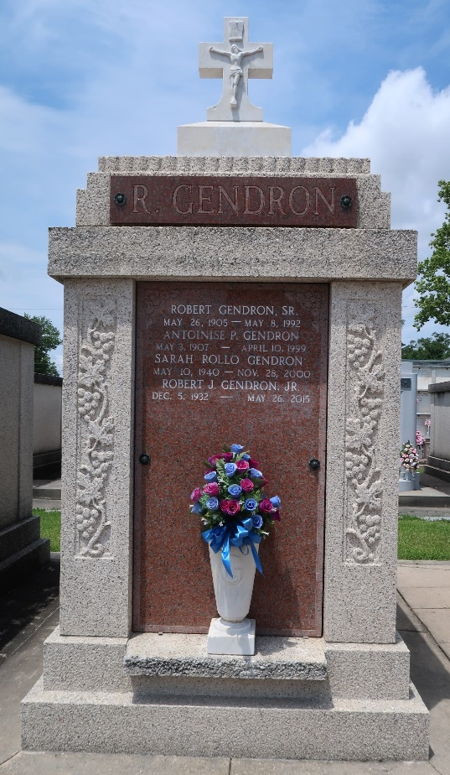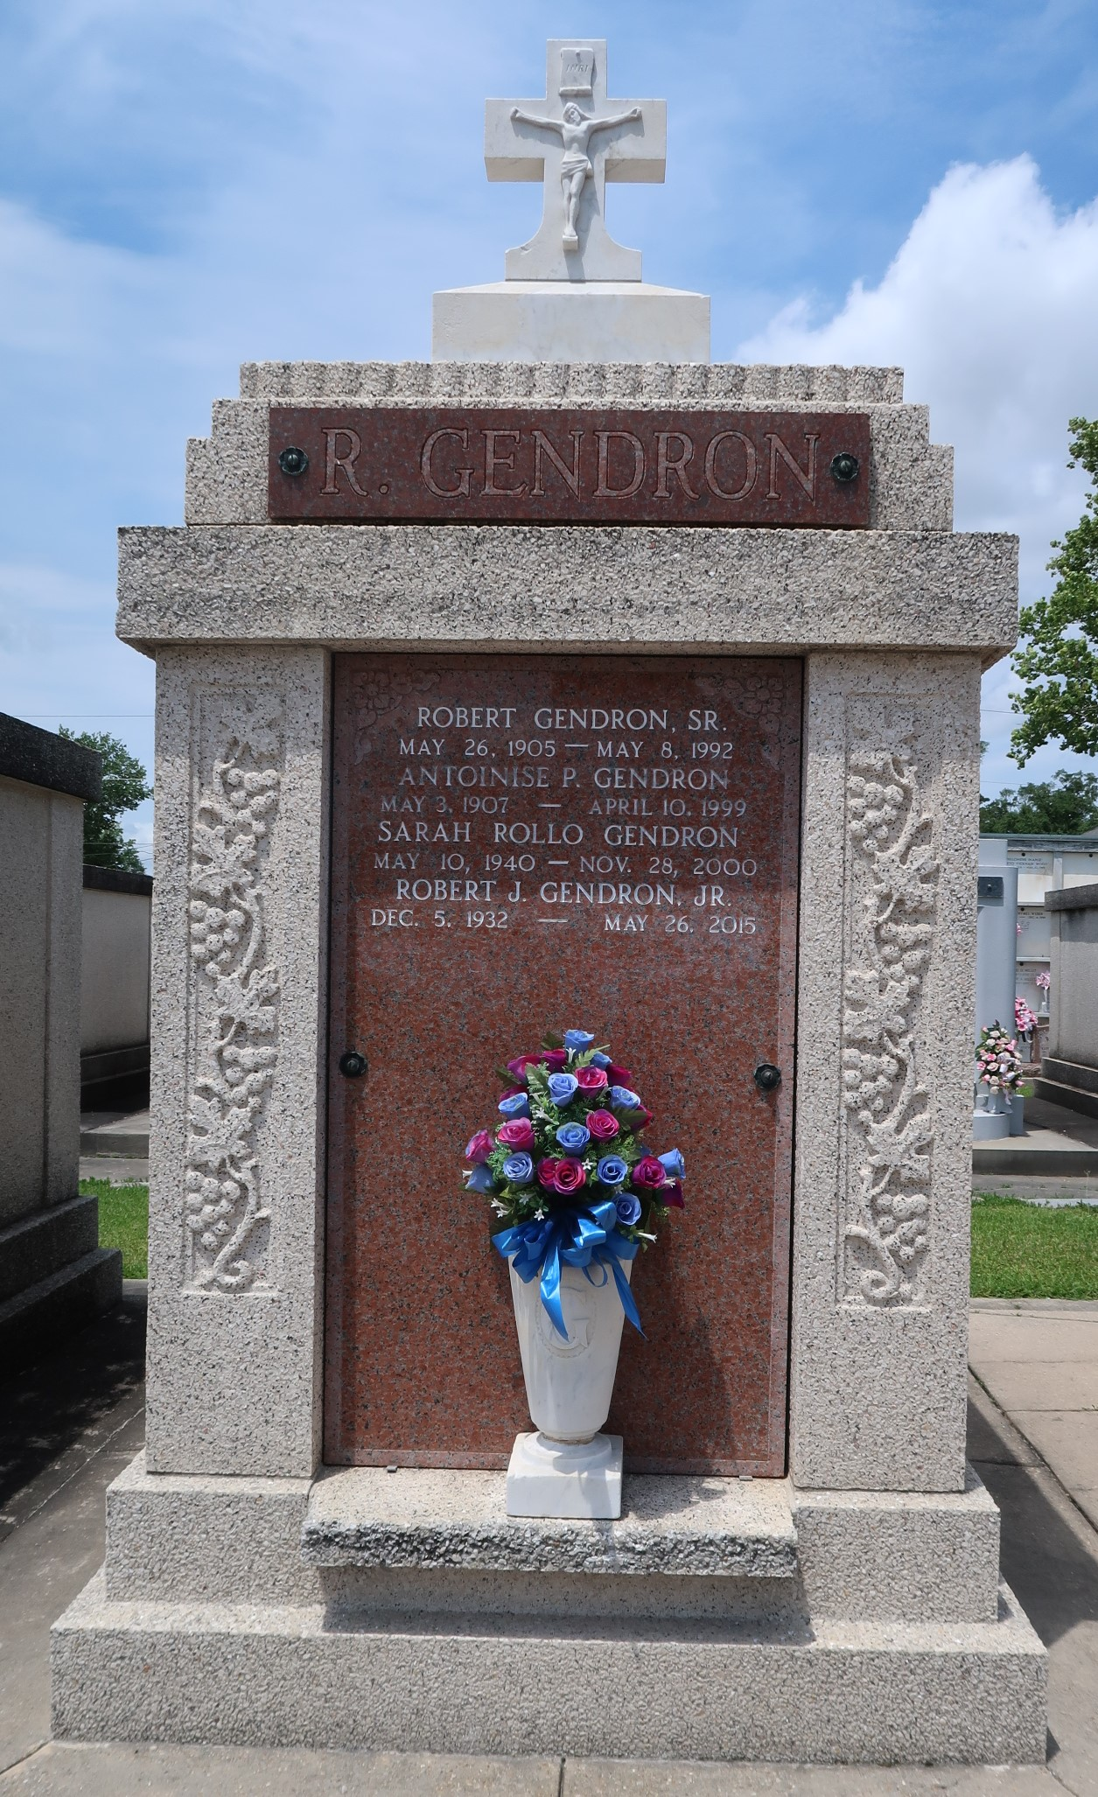

Antoinise Perilloux Gendron died on Saturday, April 10, 1999.
Beloved wife of the late Robert Gendron. Mother of Robert Gendron Jr, Gloria G Roussel and the late Ruby G Guidry. Sister of Agney Perilloux and the late Joseph Perilloux, Denise Rushing and Jeannette Lapping. Also survived by 10 grandchildren, 15 great grandchildren and 6 great great grandchildren. Age 91, a native and resident of Laplace, LA.
Relatives and friends of the family are invited to attend the funeral. Services at Millet Guidry Funeral Home, 2808 West Airline Hwy, Laplace, LA, on Tuesday, April 13, 1999. Followed by Religious services at St Joan of Arc Catholic Church, Laplace, LA, at 10:00 AM. Interment in St Peter Cemetery, Reserve, LA.
Unknown source

