Jorda Elphege Gendron
May 15, 1895 – December 12, 1965
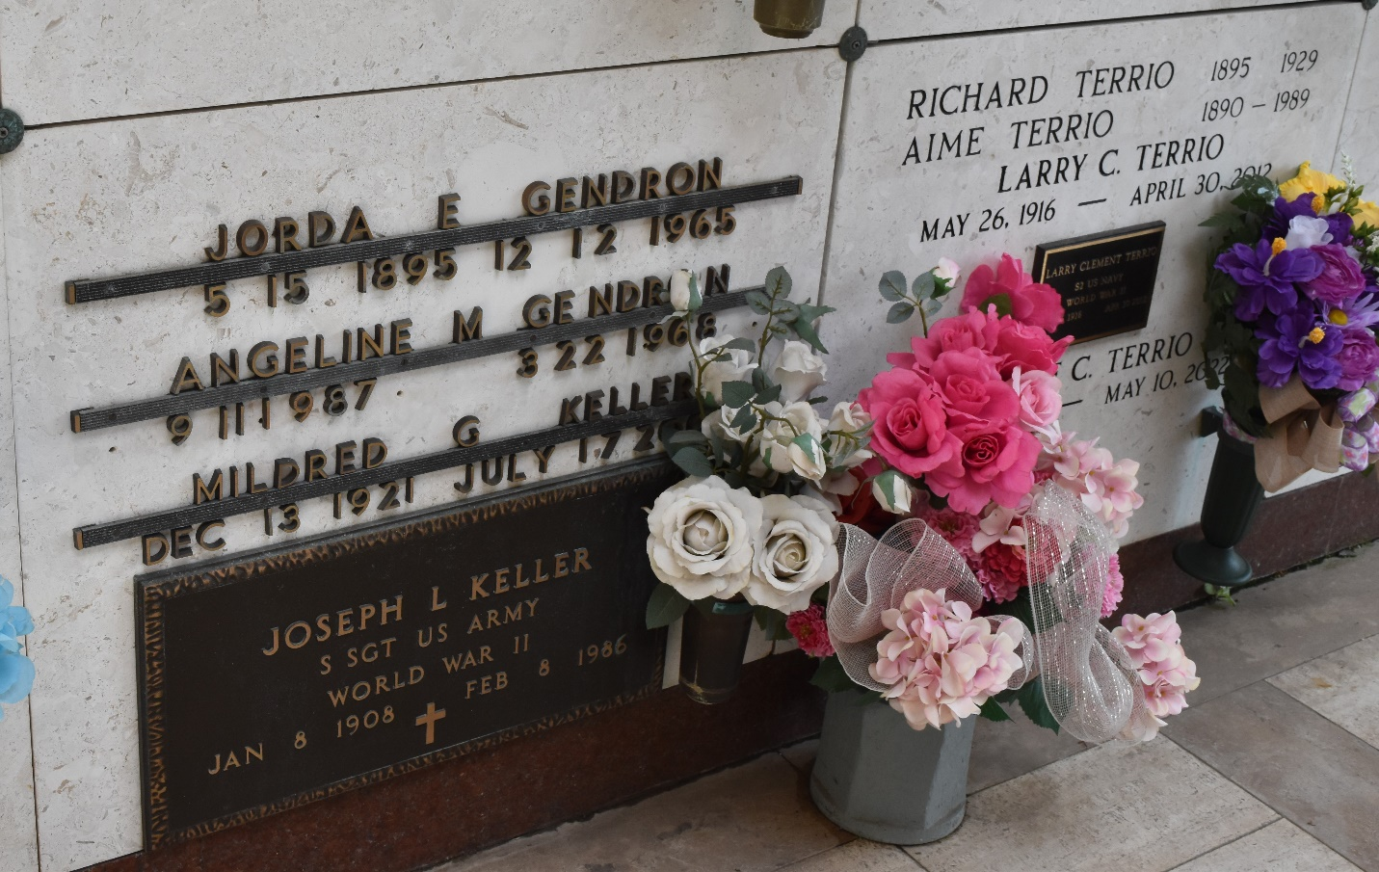

U.S., World War II Draft Registration Cards, 1942
Name Jorda Elphege Gendron
Gender Male
Birth Date 15 May 1895, LaPlace, Louisiana
Age 46
Residence Place La Place, Louisiana, USA
Military Draft Date 1942
Next of Kin E. H. Alexander

