Josephine (Catalano) Gendron

November 10, 1931 – May 12, 2016

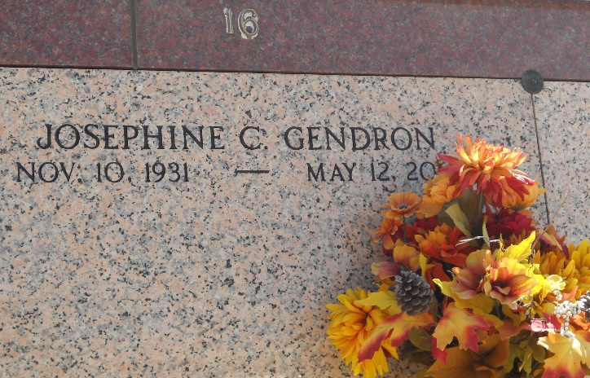

Photo by Team T-Lo

Josephine Catalano Gendron died May 12, 2016 at the age of 84.  
 Beloved wife of the late Raymond Roy Gendron, Sr. Mother of Karen G. Kiefer (Dean), Maria G. Lambert (Patrick), Tracey G. Boyle (Cary), Raye Gendron, Judy G. Kline (Jeffrey), Raymond Gendron, Jr. (JoAnn). Daughter of the late Congetta Pecoraro Catalano and Michael Catalano. Sister of the late Philip Catalano, Mary D’Amico, Catherine Barrios, Dominica Pere, Sam Catalano and Guy Catalano. Grandmother of Patrick Lambert, Jr., Natalie Lambert Williams, Gregory Boyle, Christopher Boyle, Hannah Kline, Paul Kline, Raymond Gendron, III, Jenna Gendron and Ruben Gendron. Great-grandmother of Anna Maria Williams. Devoted friend of the family, Jerry Bordelon.  
 Relatives and friends are invited to attend the Funeral Mass at Ascension of Our Lord Catholic Church, 1900 Greenwood Dr., LaPlace, LA on Monday, May 16, 2016 at 12:00 p.m. Visitation will be held at the church from 9:30 a.m. to 12:00 p.m. Interment in St. Peter Cemetery. Arrangements by Millet-Guidry Funeral Home.  
  
TheNewOrleansAdvocate.com

May 13 to May 20, 2016