Marie Leontine (Vicknair) Gendron

Aka Mrs. Elphege Gendron

January 11, 1862 – June 10, 1952

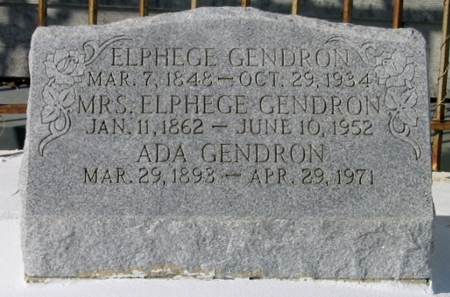

Photo by Bobby

GENDRON - On Tuesday, June 10, 1952, at 12:15 o'clock p.m., LEONTINE VICKNAIR, wife of the late Elphege Gendron; mother of Mrs Edmond Alexander, Mrs James Keating and Miss Ada Gendron, Elton J, Pordo, the late William Gendron, and Mrs McDuffy Keating; also survived by several grandchildren; age 90 years, 5 months; a native of Laplace, La.

Relatives and friends of the family are respectfully invited to attend the funeral, which will take place on Wednesday, June 11, 1952, at 4 o'clock p.m., from Millet Funeral Home, Reserve, La. Religious services at St Joan of Arc church, Laplace, La. Interment in St Peter Cemetery, Reserve, La. Millet Funeral home in charge.

The Times-Picayune, New Orleans, Louisiana

11 Jun 1952, p. 2