Raymond Roy Gendron

August 31, 1931 – June 5, 2015

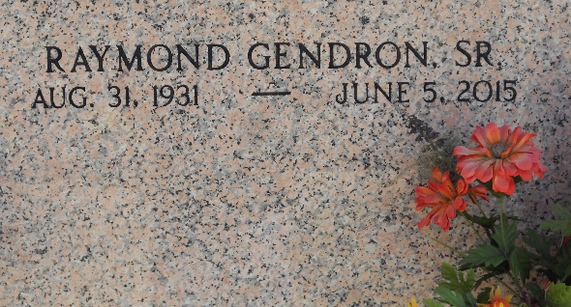

Photo by Team T-Lo

Raymond Roy Gendron, Sr. died June, 5, 2015 at the age of 83.

Beloved husband of Josephine Catalano Gendron for 60 years. Father of Karen G. Kiefer (Dean), Maria G. Lambert (Patrick), Tracey G. Boyle (Cary), Raye Gendron, Judy G. Kline (Jeffrey), Raymond Gendron, Jr. (JoAnn).

Son of the late Lillian deBautte Gendron and Damas Gendron. Brother of Myrtle Gendron Mancuso. Grandfather of Patrick Lambert, Jr., Natalie Lambert Williams, Gregory Boyle, Christopher Boyle, Hannah Kline, Paul Kline, Raymond Gendron, III, Jenna Gendron and Ruben Gendron.

Mr. Gendron graduated from Leon Godchaux High School in 1948 and proudly served in the US Marine Corps. He was an Allstate Insurance Agent since 1960, former employee of Shell Chemical, held his real estate license for over 50 years, a member of Knights of Columbus for over 50 years and served on the Board of Directors for the American Bank.

Relatives and friends are invited to attend the Funeral. Visitation will be held on Monday, June 8, 2015 at Millet-Guidry Funeral Home, 2806 West Airline Highway, LaPlace, LA from 6:00 p.m. until 9:00 p.m., and on Tuesday, June 9, 2015 from 8:00 a.m. until 9:30 a.m. The Mass of Christian Burial will begin at 10:00 a.m. St. Joan of Arc Catholic Church, 529 w. 5th St., LaPlace, LA. Interment in St. Peter Cemetery. To view or sign the online guest book, please visit [www.milletguidry.com](http://www.milletguidry.com)

The Times-Picayune, New Orleans, Louisiana

June 6-7, 2015