Robert J. Gendron Jr.
December 5, 1932 – May 26, 2015

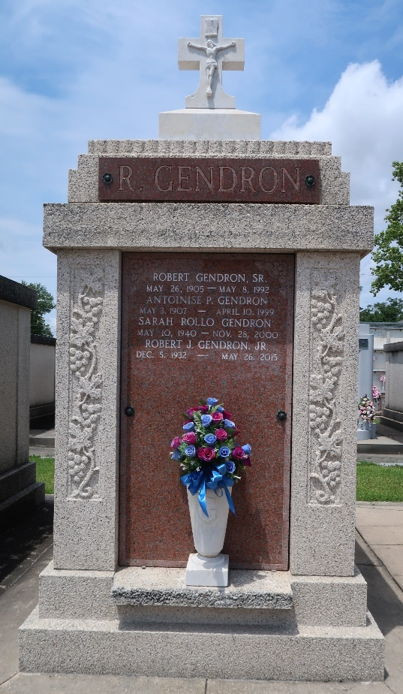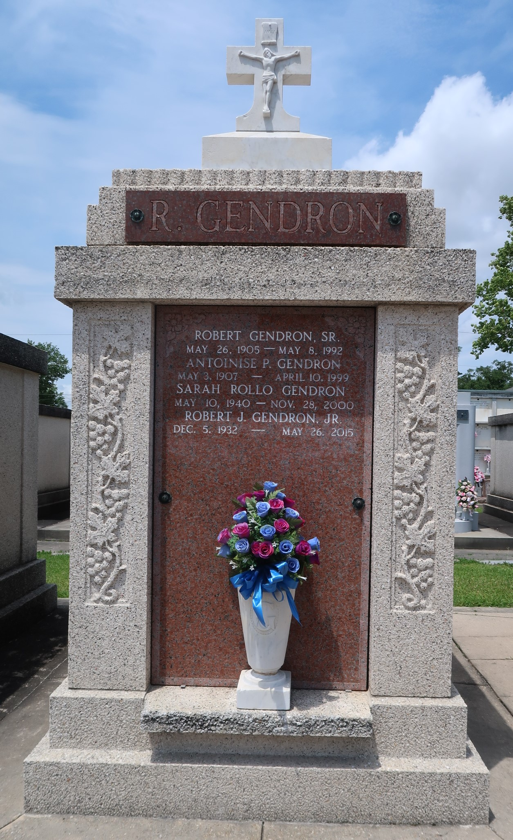

Robert J. Gendron, Jr. passed away peacefully at the home of his daughter in Gonzales on Tuesday, May 26, 2015 at the age of 82. He was a native and lifelong resident of LaPlace, LA.
Beloved husband of the late Sarah R. Gendron. Loving father of Darlene Keyser, Robin Vicknair (James), Gaylyn St. Martin (Daniel), and Bryan Gendron. Grandfather of Heidi Vicknair, Jayme Vicknair, Brittany Vicknair (Brandon St. Martin), Benjamin Gendron and the late Taylor Adams. Great-grandfather of Hannah and Bryson St. Martin. Son of the late Robert J. Gendron, Sr. and Antoinise Perilloux Gendron. Brother of Gloria Roussel and the late Ruby Guidry.
The family would like to give special thanks to St. Catherine's Hospice, LLC staff for their compassion and care.
Relatives and friends are invited to attend the Funeral Service at Millet-Guidry Funeral Home, 2806 W. Airline Hwy, LaPlace on Saturday, May 30, 2015 at 11:00 a.m. Visitation will begin at 9:00 a.m. Interment in St. Peter Cemetery. To view or sign online guest book please visit www.milletguidry.com
The Times-Picayune, New Orleans, Louisiana
May 26-29, 2015

