Robert Gendron Sr.
May 26, 1905 – May 8, 1992

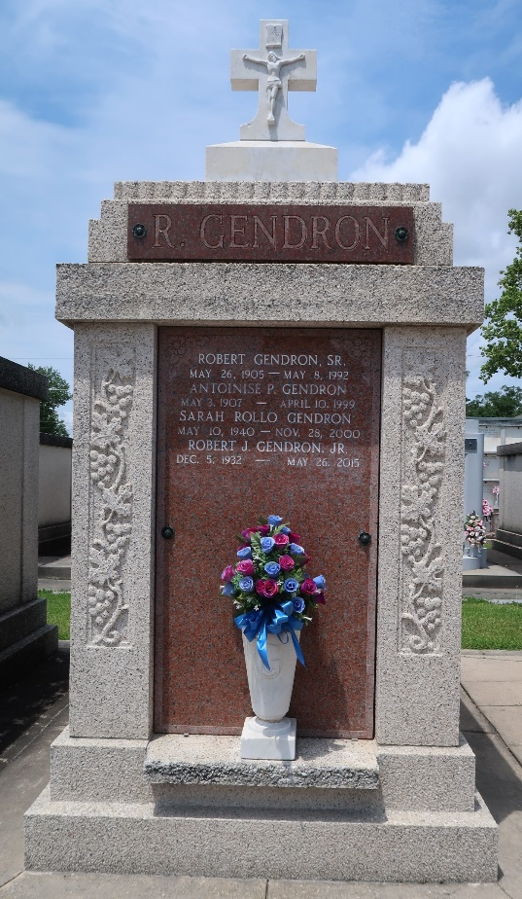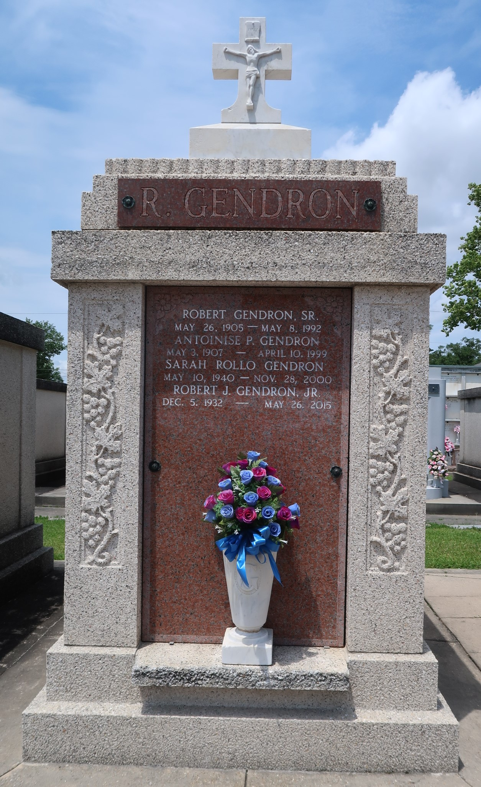

Robert Gendron Sr died on Friday, May 8, 1992 at 7:15 o'clock AM.
Beloved husband of Antoinise P Gendron. Father of Gloria P Elliot of Paulina, LA, Robert Gendron Jr of Laplace and the late Mrs Russell (Ruby) G Guidry. Survived by 10 grandchildren and 14 great grandchildren, also 1 brother, Damas Gendron, and the late Noe, Jules, Leon, Antoine, Paul and 1 sister, Mrs Zoe Clement. A retired employee of Godchaux Henderson Sugar Refinery. Age 86 years, a resident of Laplace, LA.
Relatives and friends of the family are invited to attend the funeral services at Millet Guidry Funeral Home, 2806 West Airline Hwy, Laplace, on Saturday, May 9, 1992 at 10 o'clock AM. Followed by Religious services in the funeral home chapel. Interment in St Peter Cemetery, Reserve, LA.
The Times-Picayune, New Orleans, Louisiana
9 May 1992

