Sarah (Rollo) Gendron
May 10, 1940 – November 28, 2000

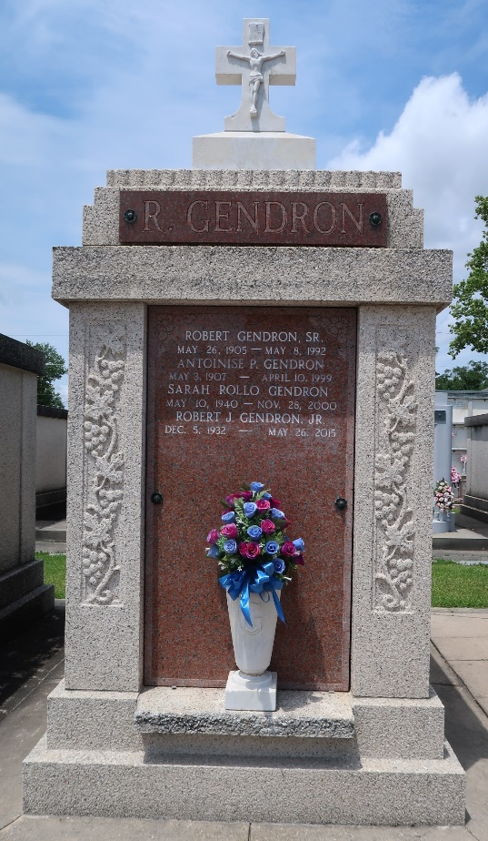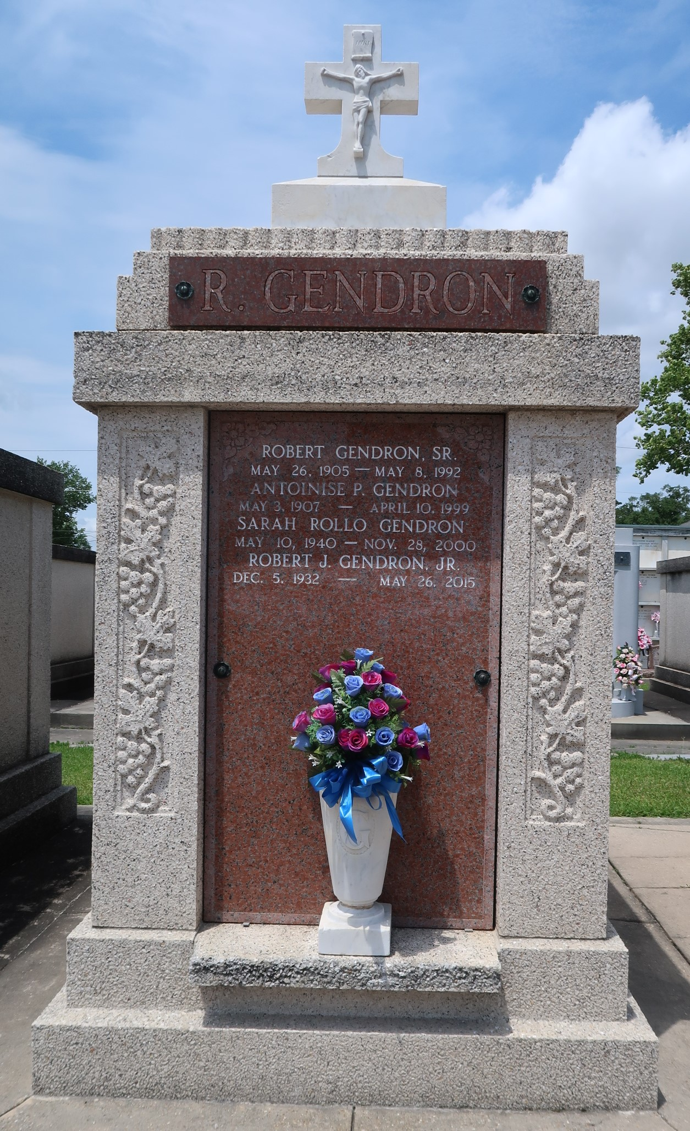

Sarah Rollo Gendron, on Tuesday, November 28, 2000 at 7:35 P.M.
Beloved wife of Robert J Gendron Jr. Mother of Darlene G Keyser, Robin G Vicknair, Gaylyn G Adams and Bryan J Gendron. Mother-in-law of James A Vicknair Jr and Edward L Adams Jr. Daughter of the late Joseph and Mamie Milioto Rollo. Sister of Vincent Rollo. Grandmother of Heidi, Jayme and Brittany Vicknair, Benjamin Gendron and Taylor Adams. Aged 60 years. A native and resident of Laplace, LA.
Relatives and friends of the family, also members of St Joan of Arc Ladies Altar Society, are invited to attend the funeral services at Millet Guidry Funeral Home, 2806 W Airline Hwy, Laplace, on Friday, December 1. Followed by religious services at St Joan of Arc Catholic Church at 12 noon. Burial in St Peter Cemetery, Reserve, LA.
The Times-Picayune, New Orleans, Louisiana
November 30, 2000
**

LAPLACE - Sarah Rollo Gendron, 60, a native and resident of LaPlace, died Nov. 28. She was the wife of Robert J. Gendron Jr. and mother of Darlene Keyser, Robin Vicknair, Gaylyn Adams and Bryan Gendron. She was also the daughter of the late Joseph and Mamie Milioto Rollo and sister of Vincent Rollo. She is also survived by five grandchildren. Services were Dec. 1 at St. Joan of Arc Catholic Church, LaPlace, with interment at St. Peter Cemetery, Reserve.
L'Observateur, LaPlace, Louisiana
December 2, 2000

