Charles Gregory Georgel

December 28, 1948 – February 25, 2011

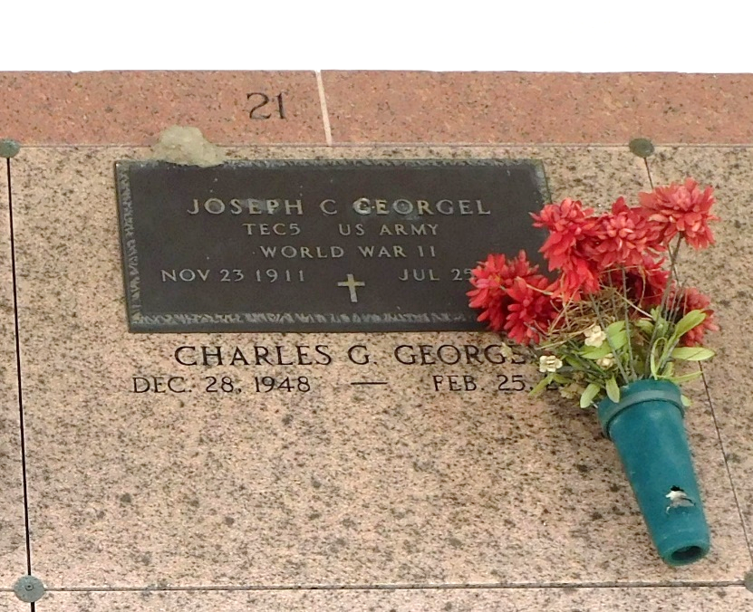

Photo by Team T-Lo

Charles Georgel passed away on Friday, February 25, 2011. Beloved son of the late Joseph and Mary Georgel. Also survived by cousins, nieces and nephews. Age 62. A native and resident of Montz, La. Relatives and friends are invited to attend services. Visitation at Millet-Guidry Funeral Home, 2806 W. Airline Hwy., LaPlace, La., on Thursday, March 3, 2011 from 9:00 am to 10:00 am, followed by Religious Services in the Funeral home chapel at 10:00 am. Burial in St. Peter Cemetery, Reserve, La.

The Times Picayune, New Orleans, Louisiana

March 2, 2011

\*\*

Charles Georgel, 62, passed away on Friday, Feb. 25, 2011. He was the beloved son of the late Joseph and Mary Georgel. He is also survived by cousins, nieces and nephews. He was a native and resident of Montz. Visitation and services were held at Millet-Guidry Funeral Home of LaPlace on Thursday, March 3, 2011. Burial followed in St. Peter Cemetery in Reserve.

L'Observateur, LaPlace, Louisiana

Saturday, March 5, 2011