Myrtle (Fournier) Giger
October 10, 1927 – October 3, 1993

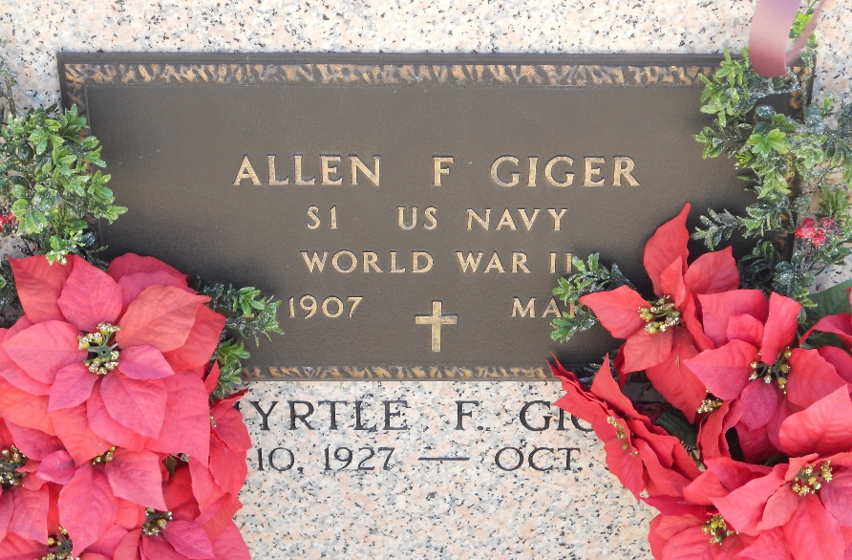

A Mass of Christian burial was celebrated at 10 a.m. today at St. Peter Catholic Church in Reserve for Myrtle Fournier Giger, 85, a native of Raceland and resident of Reserve, who died at 12:31 p.m. Sunday Oct. 3.

Burial was in St. Peter Catholic Church cemetery in Reserve.

She was preceded in death by her husband, Allen F. Giger; parents, John and Therese Matherne Fournier; and a brother, Junius Fournier.

Millet-Guidry Funeral Home of Reserve was in charge of arrangements.

Unknown source

