Thelma (Barre) Gillman
June 28, 1913 – February 2008
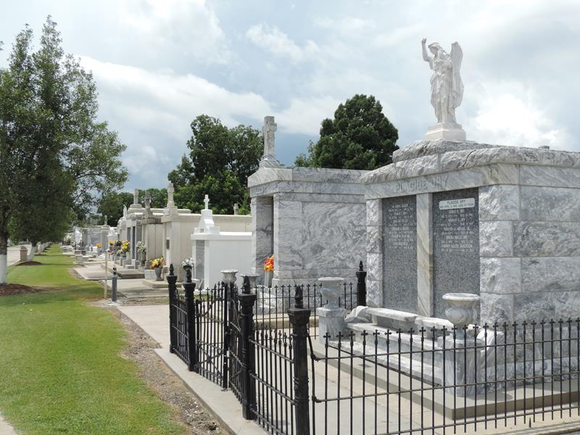

Thelma Barre Gillman on Friday, February 8, 2008 at 4:00 p.m. Beloved wife of the late Ray Gillman. Daughter of the late Pierre Klebert Barre and Martha Rodrigue Barre. Sister of Klebert Barre, the late James Barre and Laurence Vicknair. Also survived by numerous nieces, nephews, great-nieces and -nephews. Age 94 years. A native of Pikes Peak, LA and a resident of LaPlace, LA.
Relatives and friends are invited to attend services. Visitation at St. Joan of Arc Catholic Church, LaPlace, LA on Monday, February 11, 2008 from 9:00 a.m. until 11:00 a.m. Followed by Religious Services at the Church at 11:00 a.m. Burial in St. Peter Cemetery, Reserve, LA. Arrangements by MILLET-GUIDRY L.L.C. FUNERAL HOME, LaPlace, LA.
Times-Picayune, New Orleans, Louisiana
February 10, 2008

