Van Haven Gilmore Jr.
October 10, 1932 – December 26, 2007

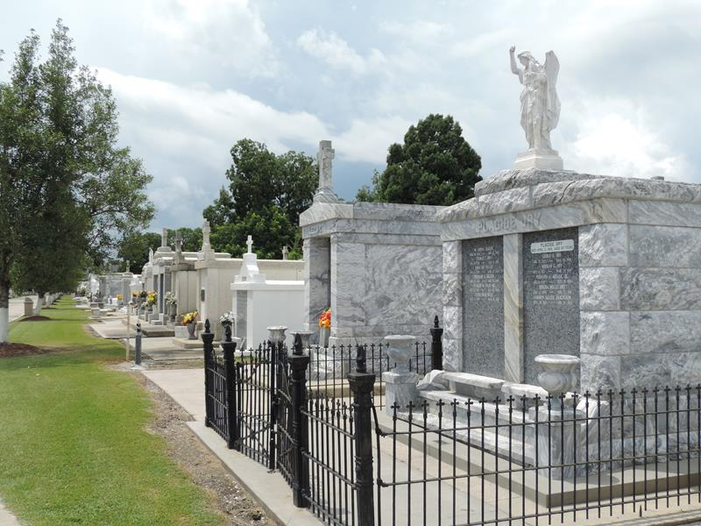

Van Haven Gilmore, Jr. - A resident of LaPlace for the past 44 years and a native of Lake Charles, he died at 4:47 a.m. Wednesday, Dec. 26, 2007.
Visitation at St. Joan of Arc Catholic Church, 529 W. Fifth St., LaPlace, on Friday, Dec. 28, from 9:30 a.m. until religious service at 11:30 a.m. Burial in St. Peter Cemetery, Reserve.
He was the beloved husband of Emma Lane Gilmore, of LaPlace; and father of Van Haven Gilmore III, of Baton Rouge, and Kathryn Lane Gilmore, of LaPlace.
He was a member of the St. Joan of Arc Catholic Church Choir, founding member of the Plantation District Amateur Radio Club, an amateur photographer, an Eagle Scout who was an active leader in Troop 312, LaPlace, a graduate of LSU with a bachelor's degree in chemical engineering and a volunteer with St. John Emergency Preparedness.
Arrangements by Millet-Guidry Funeral Home of LaPlace. In lieu of flowers, donations preferred to the American Heart Association, American Lung Association or Masses.
Published by Legacy Remembers on Dec. 27, 2007

