Melissa (Keller) Goines

June 5, 1963 – December 14, 2011

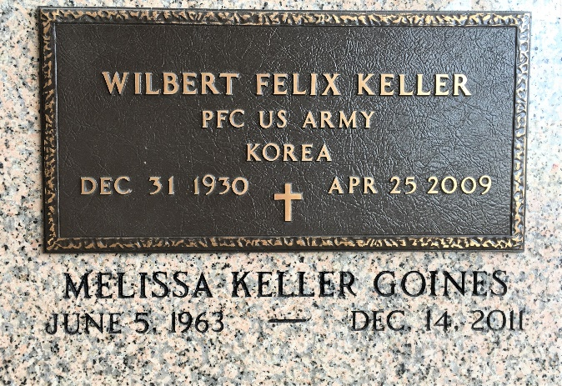

Photo by Team T-Lo

Melissa Keller Goines, on Wednesday, December 14, 2011 at her home in Reserve, LA. Daughter of Josephine "Josie" Mitchell Keller and the late Wilbert Keller. Wife of Ivy Goines. Mother of Joshua J. Goines. Sister of Wilbert Jude Keller (DeVita), Lori Anne Keller and Wayne Michael Keller (Kelly). Also survived by seven nieces and nephews, cousins, other relatives and friends. Age 48 years. A native and resident of Reserve, LA.

Relatives and friends of the family also pastors, officers and members of New Wine Christian Fellowship, New Orleans First Seventh-Day Adventist Church, Pioneer Memorial Church of Barring Spring, Michigan and all neighboring churches, employees of Bob Goines Detailing, St John Parish School Board, Faculty, staff and students of LaPlace Elementary School, Staff of the surgery Department of Huntsville Alabama Hospital and the Veterans Administration Medical Center of Minneapolis, MN, employees of USDA National Finance Center of New Orleans, LA, administration, physicians and nursing staff of East Jefferson Hospital and St. John Parish DaVita Dialysis Center are invited to attend the funeral at New Wine Christian Fellowship, 1929 West Airline Highway, LaPlace, LA on Wednesday, December 21, 2011 at 11:00 AM. Rev. Neil Bernard, Pastor, Glenn Farinola, Pastor of New Orleans First Seventh-Day Adventist Church, Officiating. Interment St Peter Cemetery, Reserve, LA. Visitation at the above named church from 9:00 AM until Service Time.

In lieu of flowers donate a unit of blood in Melissa's name or Sickle Cell Foundation. SERVICED BY ROBOTTOM

The Times-Picayune, New Orleans, Louisiana

Dec. 19 to Dec. 20, 2011