Cecile (Cambre) Gonzales
December 17, 1916 – March 24, 1958

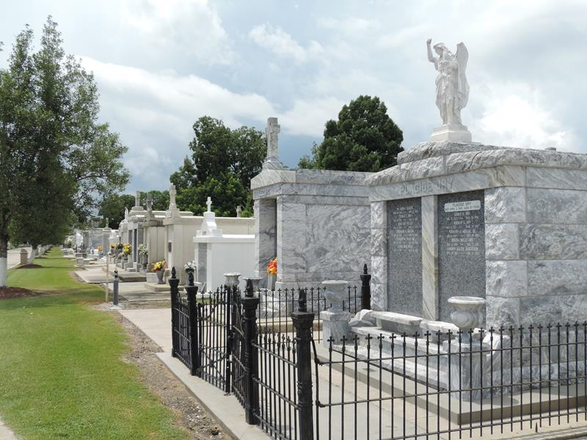
Photo by Team T-Lo

Wife of Sidney Gonzales and daughter of the late Harris Cambre and Clementine Fourroux Cambre. Mother of Sidney J, Patricia C, Leonard P, Kenneth D, Donald F, and Terry G Gonzales. Sister of Henry, Lance, Melicin, Frank, Louis, Jane, and Albert Cambre, Mrs. Irma Michel and Mrs. Alberta Machon. She was age 41 years, 3 months, and 7 days at time of death and a resident of Garyville, LA.

The Times-Picayune, New Orleans, Louisiana
March 26, 1958, p. 2

