Amelia Noelle Goodwin
October 10, 2014 – October 10, 2014

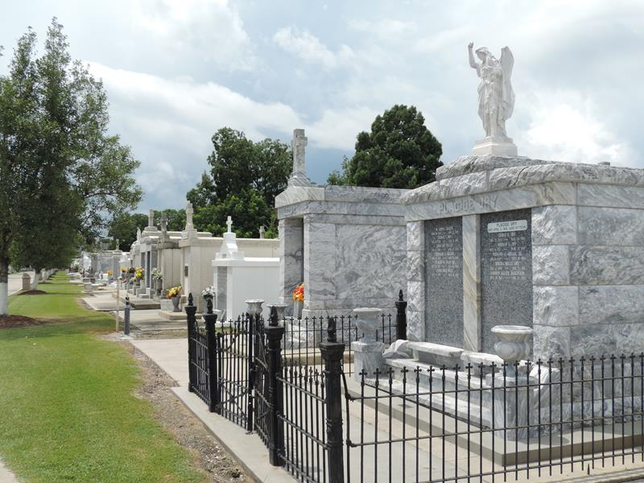

Amelia Noelle Goodwin was born and passed away on October 10, 2014.
She will be forever in our hearts.
Survivors
Zachary Goodwin and Madeleine Duhe, Parents
Nicole Boudreaux Goodwin, Noelle Juneau Duhe and James Duhe, Jr., Grandparents
Brooke Goodwin, Eden Goodwin, and Emily Duhe, Aunts
Jeffrey Goodwin II, James “Buddy” Duhe III, and Benjamin Duhe, Uncles
Services
Visitation: Saturday October 18, 2014, 9:00 a.m. at St. Joan of Arc Catholic Church, 529 W 5th St., LaPlace, LA 70068
Mass of Christian Burial: Saturday October 18, 2014, 10:00 a.m. at St. Joan of Arc Catholic Church
Burial: St. Peter Cemetery, 1550 Louisiana 44, Reserve, LA 70084

Unknown source (probably Rose Lynn Funeral Home, Lutcher, Louisiana)

