Lynn Marie Gordon
February 16, 1960 – March 18, 2023
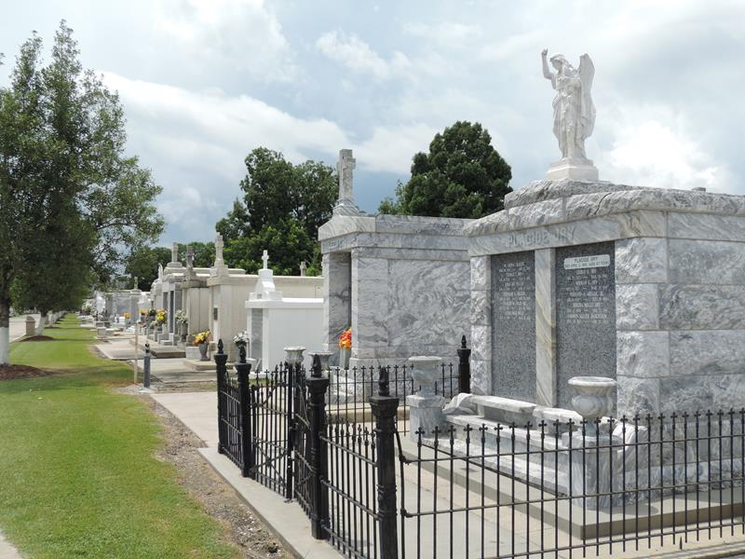

Lynn Marie Gordon passed away on March 18, 2023 at the age of 63.
She is preceded in death by her parents Mahlon and Mary Gordon and her beloved companion of 36 years Calvin Vicknair.
She is survived by her daughter Stephanie Mollere (Chad) and her siblings: Kevin Gordon, Brent Gordon and Randy Gordon (Kristina) and by her 6 grandchildren: Stephen J. Vicknair, Caleb Vicknair, Heather Prine, Karen Prine, Erick Barker and Destiny Collins and by her 2 great-grandchildren: Hollianna Perilloux and Holly Vicknair. She is also survived by 2 nieces, 3 nephews and numerous other family and friends.
Relatives and friends are invited to attend a Memorial Service at 11:00 AM on Tuesday, March 28, 2023 at Millet-Guidry Funeral Home, 2806 W. Airline Hwy, LaPlace, LA 70068. Visitation will begin at 8:30 AM. Interment will be in St. Peter Catholic Cemetery in Reserve, LA.
Millet – Guidry Funeral Home, LaPlace, Louisiana

