Irene Margaret (Schexnayder) Gorio
March 10, 1943 – September 8, 2014

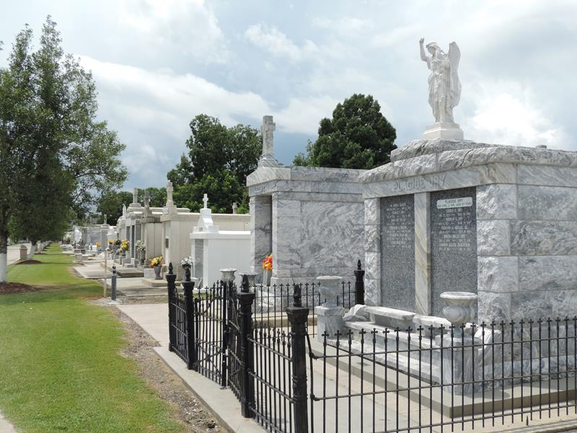

Irene Schexnayder Gorio died on Monday, September 8, 2014. Beloved wife of Earl Gorio. Mother of Shani G. Asprion and Earl Gorio Jr. Grandmother of Hayden and Mallori Asprion and Ainsley Gorio. Daughter of the late Wilton and Wilda Schexnayder. Sister of Wayne, Ronald, Kevin, Joel, Camille and Lowell Schexnayder, Mary Lebouef and the late Randall Schexnayder. Age 71. A native of Gramercy , former resident of Garyville and a resident of Hammond.

Relatives and friends are invited to attend services. Visitation at St. Hubert Catholic Church, Garyville, LA on Thursday September 11, 2014 from 9:00am to 11:00am, followed by Mass at 11:00am. Burial in St. Peter Cemetery, Reserve, LA. Arrangements by Millet-Guidry Funeral Home, LaPlace, LA.

The New Orleans Advocate, Louisiana
Sep. 8 to Sep. 11, 2014

