Bessie (Acosta) Grady
December 28, 1948 – February 25, 2011

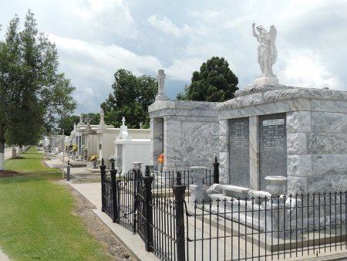
Photo by Team T-Lo

Bessie Acosta Grady On Wednesday, August 4, 2004 At 2:52 Pm. Beloved Wife Of The Late Gordon S. Grady. Mother And Mother-In-Law Of Glendoline And Neal Tobey, Dorothy And Eric Young, Glenn And Patricia Grady And The Late Gordon Grady, Jr. Daughter Of The Late Joseph And Glendoline Cambre
Acosta. Step Daughter Of The Late Luciana Tassin Acosta. Sister Of Lola Griffin, Edwin And Lawrence Acosta, Also The Late Elaine Brignac, Ronald And Leroy Acosta. Grandmother Of Arthur, Jr., And Dale Bennett, Sonny Boden, Chelsea Young, Shawn, Glenn And Michael Grady. Grandmother Of Hunter And Gage Boden And Justin And Korey Bennett. Also Survived By Numerous Nieces And Nephews. Age 90 Years. A Native And Resident Of Reserve.
Relative And Friends Of The Family, Also Members Of St. Peters Catholic Church, Ladies Altar Society And Former Employees Of Godchaux Sugar Refinery Where She Was A Switchboard Operator Are Invited To Attend Services. Visitation At Millet-Guidry Funeral Home, 2806 West Airline Hwy, Laplace On Friday, August 6, 2004 From 5-9 Pm And On Saturday From 8 Am To 9:45 Am Followed By Religious Services At St. Peters Catholic Church, 1550 Hwy 44, Reserve At 10 Am. Burial In Church Cemetery.

The Times Picayune, New Orleans, Louisiana
August 6, 2004
**

RESERVE - Bessie Acosta Grady, 90, a native and resident of Reserve, died Aug. 4. She was the mother of Glendoline Tobey, Dorothy Young and Glenn Grady. She was also the sister of Lola Griffin, Edwin and Lawrence Acosta. She is also survived by seven grandchildren and four great-grandchildren. She was a switchboard operator at Godchaux Sugar Refinery. Services are today at 10 a.m., at St. Peter Catholic Church, Reserve, with interment at the church cemetery. Visitation starts at 8 a.m.
L'Observateur, LaPlace, Louisiana
Tuesday, August 10, 2004

