Glenn George Grady
September 15, 1951 – November 5, 2008

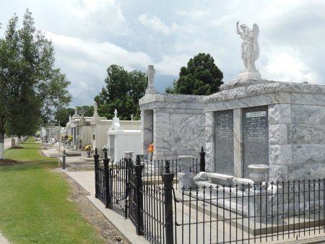
Photo by Team T-Lo

Glenn G. Grady on Wednesday November 5, 2008 at 7:30am.
Beloved husband of Patricia Jacob Grady. Father of Shawn, Glenn and Michael Grady. Son of the late Gordon and Bessie Acosta Grady. Brother of Glendoline Tobey, Dorothy Young and the late Gordon Grady, Jr. Also survived by nieces and nephews. Age 57 years. A native and resident of Reserve, LA.
Relatives and friends are invited to attend services. Visitation at Millet-Guidry Funeral Home 2806 W. Airline Hwy. LaPlace, LA on Friday, November 7, 2008 from 5:00pm to 9:00pm and on Saturday from 8:00am to 8:45am. Followed by Religious Services at St. Peter Catholic Church Reserve, La at 9:00am. Burial in St. Peter Cemetery Reserve, La.

The Times Picayune, New Orleans, Louisiana
November 7, 2008

