Donna Marie (Keating) Graham
January 2, 1962 – April 14, 2010

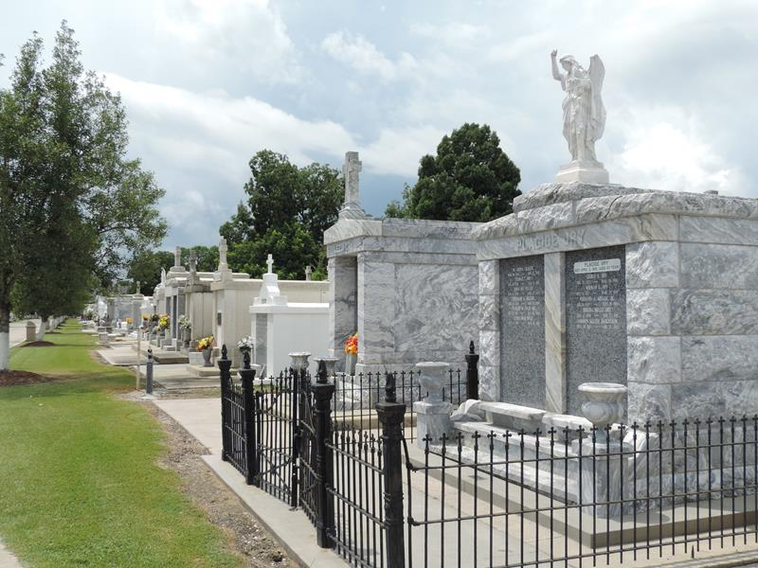

Donna Keating Graham passed away at her home in Paulina, LA on April 14, 2010 at the age of 48. Beloved wife of Joey Graham of 4 years, daughter of Godfrey Keating and the late Elaine Keating. Mother and mother in law of Adam Schexnaydre and wife Stella. Sister of Michael Keating of Mareno Valley, California, Carolyn K. Schexnaydre of New Sarpy, Barbara Falterman of Laplace, Randy Keating of Norco and the late Harold Paul and Godfrey Keating Jr. Sister in law of Maria Keating, Gilbert Schexnaydre Jr., Errol Falterman, Kim and Anita Lacombe. Stepmother to Kristyn and David Graham. Numerous nieces and nephews.
A special thank you to her two dearest friends, Jannett Cancella and Christine Simon and to St. Joseph Hospice. Lifelong native of Norco and a resident of Paulina. Donna will be sadly missed. She was an avid gardener who devoted her time to the beauty of her garden at her home.
Friends and Family are invited to attend the visitation and service on Friday, April 16, 2010 from 9:30am-noon at Alexander Funeral Home in Lutcher, LA. Burial will follow at St. Peter Mausoleum in Reserve, LA. Please leave condolences to the family at www.hcalexanderfh.com.
Times-Picayune, New Orleans, Louisiana
April 15, 2010

