Azelie (Graugnard) Granier

May 22, 1924 – August 5, 2017

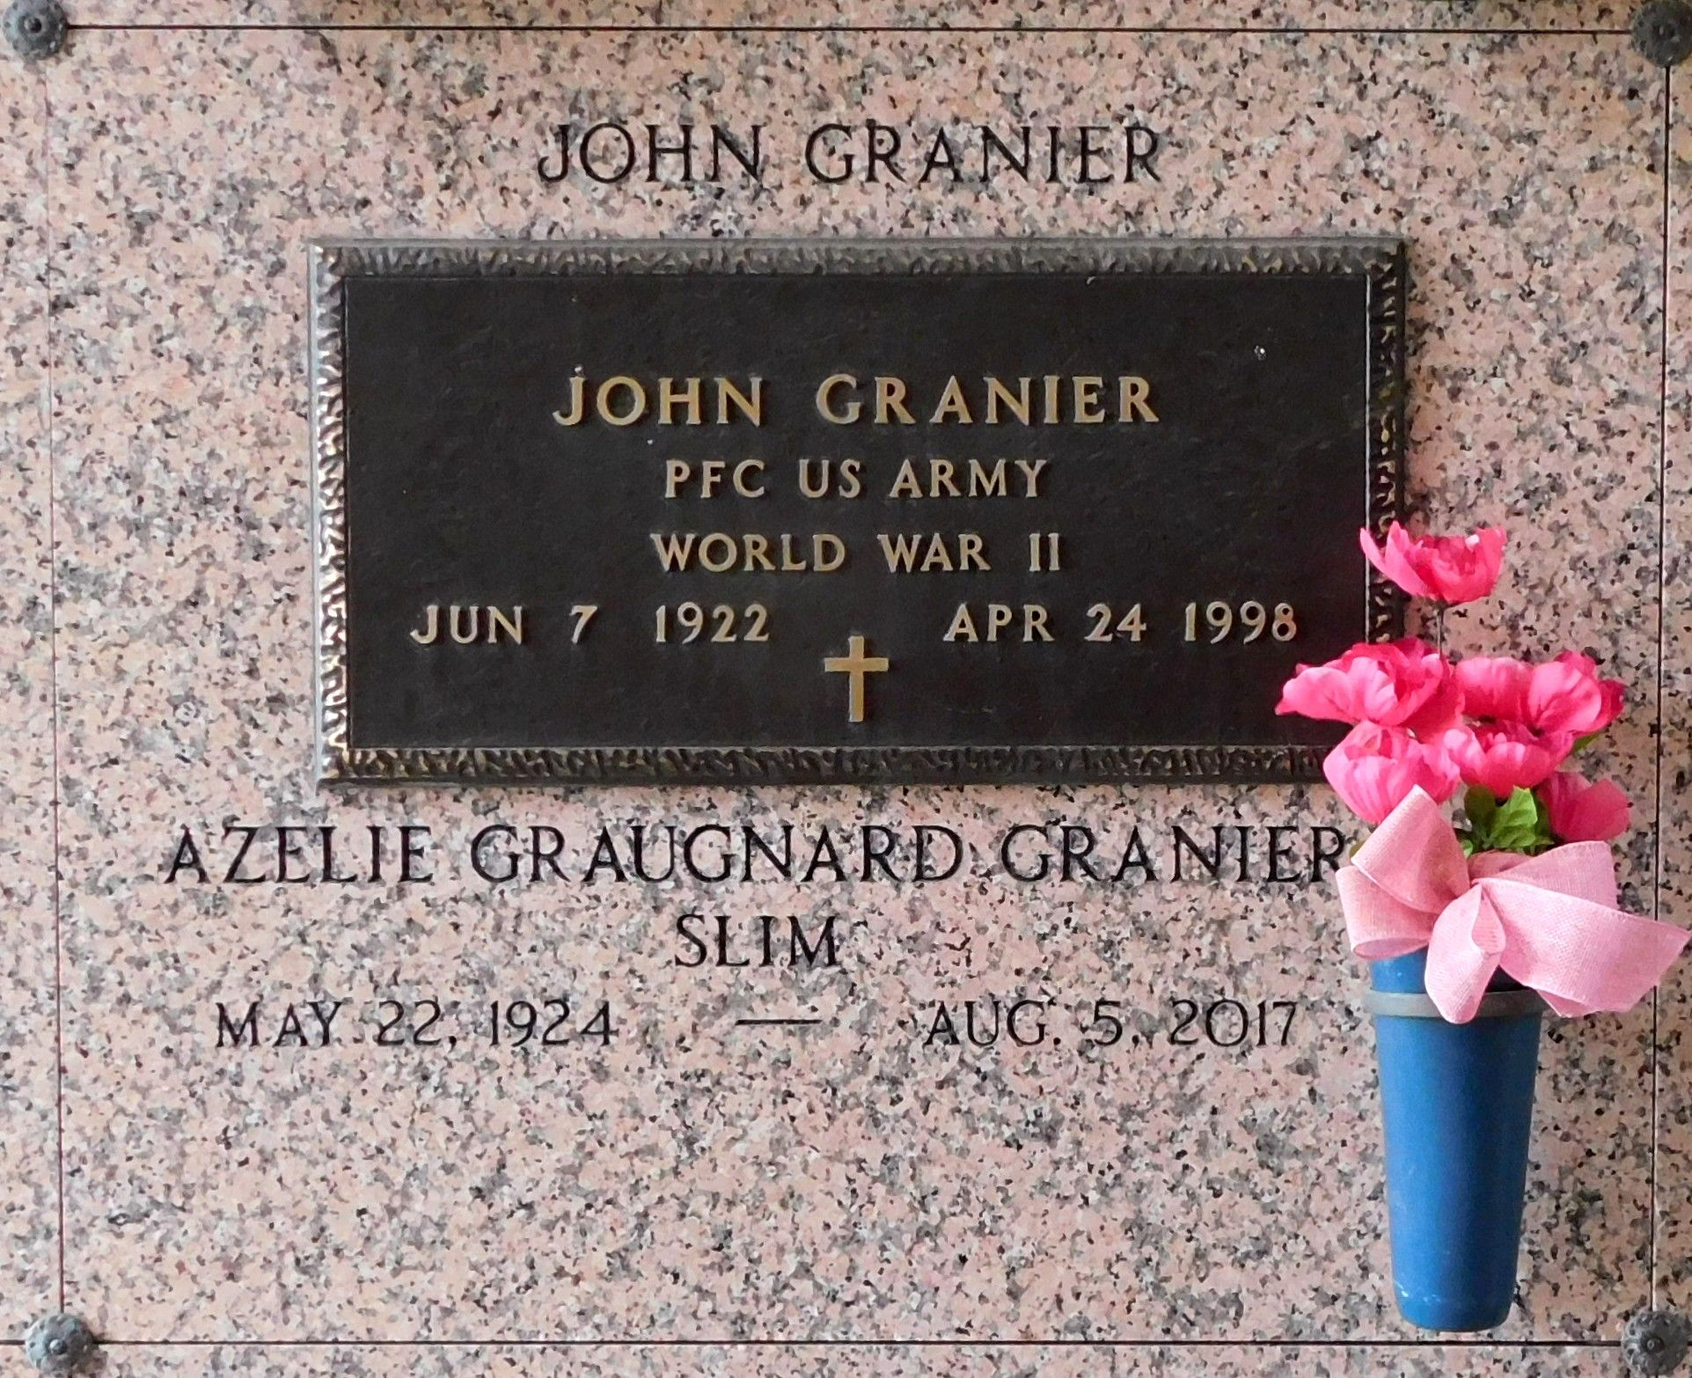

Photo by Mary Agnes Hammett

Azelie Graugnard Granier passed away on Saturday, August 5, 2017. She was 93, a native of Lions, LA and a resident of Reserve.

Wife of the late John Granier. Daughter of the late Azelie Breaud Graugnard and Emile Graugnard. Sister of Leon Graugnard, Jeanne Tregre, Marie L. Martinez, Emilie Brocato and the late Fernand Graugnard and Regina Graugnard. Also survived by many nieces and nephews.  
 Relatives and friends are invited to attend the Funeral Mass at St. Peter Catholic Church, 1550 Hwy 44, Reserve on Thursday, August 10, 2017 at 11:00 a.m. Visitation at the church from 9:00 a.m. until 11:00 a.m. Interment in St. Peter Cemetery.

Millet-Guidry Funeral Home, LaPlace, Louisiana