Claude Maurin Granier

February 25, 1922 – December 26, 2007

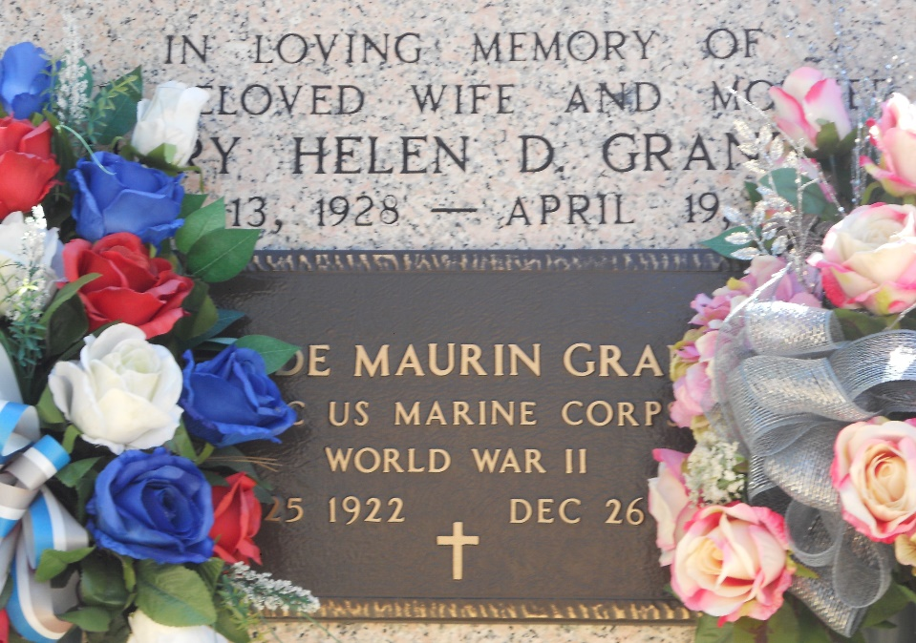

Photo by TeamT-Lo

Claude M. Granier on Wednesday, December 26, 2007 at 10:30am.

Beloved husband of the late Mary Helen Delaneuville Granier. Father of Jeff Granier, Linda Granier Ory, Doyle Granier, Patricia Roussel and Claudia Vincent. Father-in-law of Jenny Granier, Peggy Granier, Ricky Roussel and Dale Vincent. Also survived by 13 grandchildren and 2 great-grandchildren. Brother of Lorraine Lambou, Lucille Herman and the late Maurice, Irvin and Roland Granier, Beatrice Keller and Lawrence Murphy. Ex-husband of Sally Montz. Close friend of the late Florette Simon. Age 85 years, a resident of Reserve, Louisiana.

Relatives and friends of the family are invited to attend Services. Visitation at St. Peter Catholic Church, Reserve, LA on Saturday, Dec. 29, 2007 from 8am to 10am. Followed by Religious Services at the church at 10am. Burial in St. Peter Cemetery, Reserve, Louisiana. Arrangements by Millet-Guidry Funeral Home

The Times-Picayune, New Orleans, Louisiana

Dec. 28, 2007