Euphemie (Haydel) Granier
July 20, 1846 – January 1, 1928

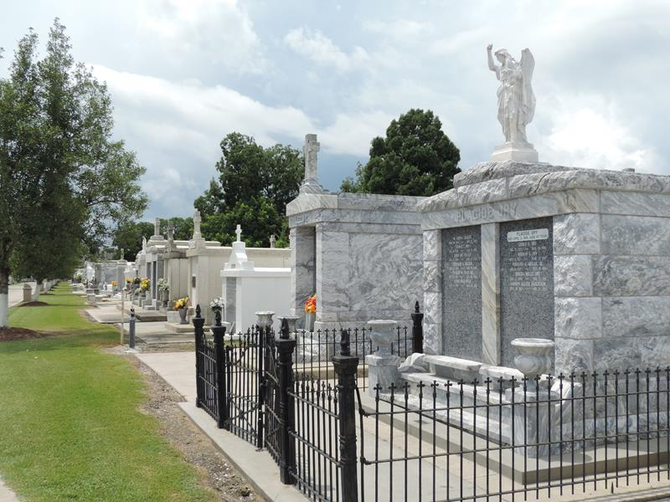

Mrs. Achille Granier, aged 84 years, died at her home at Laplace, La., after a long illness.
She is survived by her four sons, Maurice Granier of Laplace, Luke Granier of St. James and Joseph and George Granier of this parish; three daughters, Mrs. Fancale of Laplace and Mrs. Laurent Loup and Mrs. E. Babin of Plaquemine, and 49 grandchildren, besides may other relatives in this section. Funeral services were held at Reserve, La., and she was laid to rest there.
State-Times, Baton Rouge, Louisiana
Tuesday, January 10, 1928, p. 9

