Maurice J. Granier

May 16, 1910 – July 31, 1989

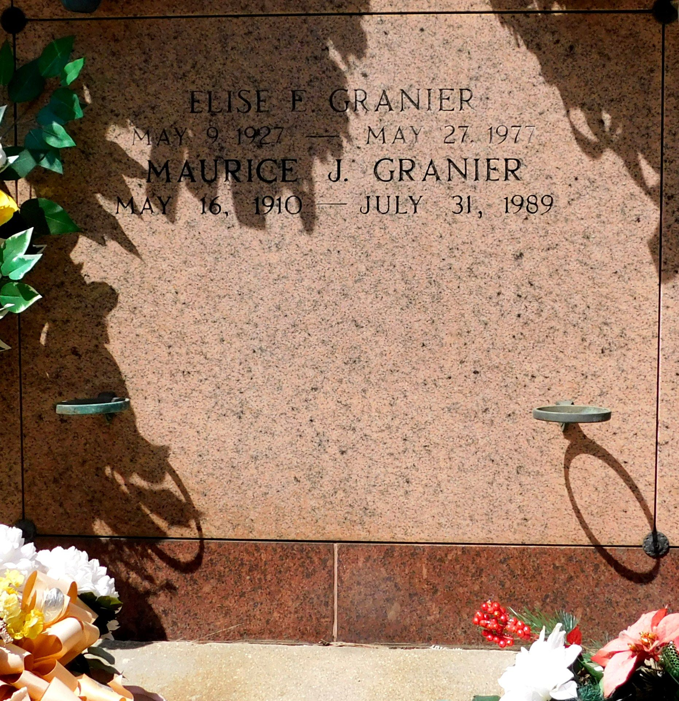

Photo by Mary Agnes Hammett

GRANIER

Maurice J. Granier on Monday, July 31, 1989 at 7:00 pm. Beloved son of the late Jean and Odelie Granier. Brother of John Granier, Audrey Guidry and Bertha Jarreau, all of Reserve, Elvia Jarreau of Baton Rouge and the late Lillian Delaneuville, Margaret Acosta, Louise Vicknair and Elise Granier. Also survived by nieces and nephews. Age 79. A native of Convent and a resident of Reserve for the past 62 years.

Relatives and friends of the family are invited to attend the funeral services at Millet-Guidry Funeral Home, 2806 West Airline Hwy., Reserve on Thursday, August 3, 1989. Followed by a mass of Christian burial in the funeral home Chapel at 10:00 am. Interment in St. Peters Cemetery, Reserve. Friends may call from 6:00 to 9:00 pm on Wednesday, August 2, 1989 and from 8:00 am until services on Thursday.

The Times-Picayune, New Orleans, Louisiana

Wednesday, August 2, 1989, p. 7B