Louise (Barbier) Granier-Ockman
1916 – January 9, 1991

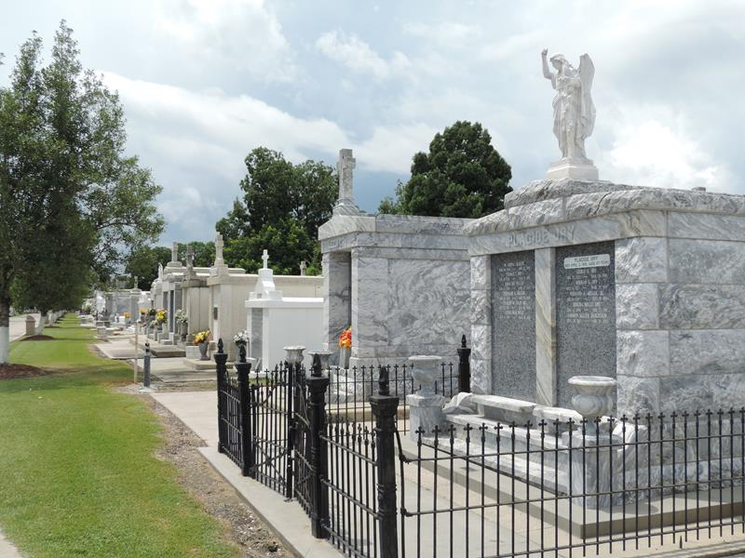

Religious services have been scheduled Saturday at 10 a.m. at St. Peter Catholic Church in Reserve for Louise Barbier Granier Ockman, 75, a native of Wallace and a resident of Reserve who died Wednesday, Jan. 9, 1991, at 5:40 a.m.
Funeral services will take place prior to the religious services at Millet Guidry Funeral Home in Reserve. Interment will be in the St. Peter Cemetery.
Visitation is scheduled Friday from 5-10 p.m. and Saturday from 8 a.m. until funeral services at the funeral home.
She was wife of Anozo Ockman; mother of Richard P. Jr., Francis and Hayward Granier, Phyllis Bourgeios and Brenda Boughan; and sister of Charles Barbier Jr., Georgine Granier, Eunice Hymel and Hilda Plaisance.
She is also survived by 12 grandchildren.
She was preceded in death by her first husband, Richard P. Granier Sr., and one sister, Adelta Falgoust.

Unknown source

