Rita Mae (LaBranche) Granier
April 10, 1926 - June 5, 2015

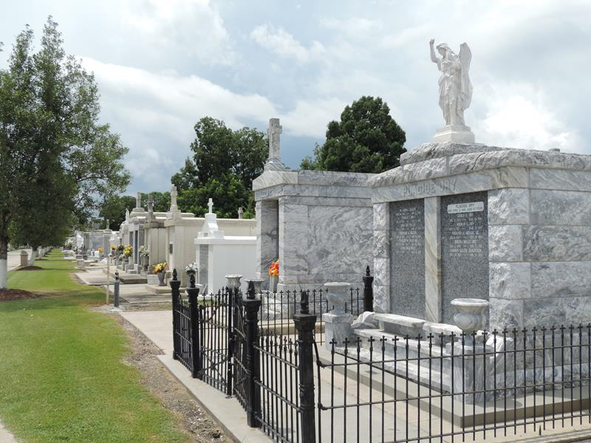

Rita Mae LaBranche Granier passed away on Friday, June 5, 2015 at the age of 89. She was a native and a resident of LaPlace, LA.
Beloved wife of the late Remie J. ‘Rip’ Granier, Sr. Mother of Marilyn G. Boudreaux (husband, Larry), Remie J. Granier, Jr. (wife, Vicky), Joann G. Moyer (husband, Dwane) and the late Glenda Stasiukiewicz (the late husband, John). Daughter of the late Leopold LaBranche and Amelia Perilloux LaBranche. Sister of the late Joseph, Paul, Henry and Earl LaBranche and Ella Foret, Melina ‘Beline’ Schexnayder, and Pauline Vicknair. Also survived by 8 grandchildren, 12 great-grandchildren and many nieces and nephews.
Relatives and friends are invited to attend the funeral. A Funeral Mass will be celebrated in the chapel of Millet-Guidry Funeral Home, 2806 W. Airline Hwy., LaPlace on Tuesday, June 9, 2015 at 1:30 p.m. Visitation from 11:30 a.m. until 1:30 p.m. Interment in St. Peter Cemetery.

Millet-Guidry Funeral Home, LaPlace, Louisiana

