Roland Edwin Granier
November 21, 1917 – March 28, 2005

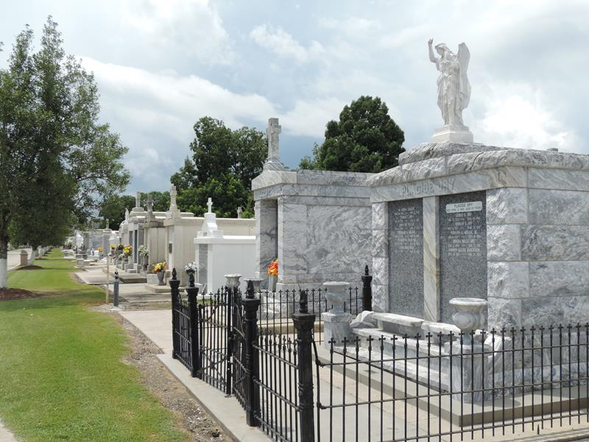

Roland E. Granier On Monday, March 28, 2005 At 10:25 P.M. Beloved Husband Of The Late Thelma (Dolly) Zeller Granier. Father Of The Late Gerard Granier. Son Of The Late Maurice, Sr. And Lena Maurin Granier. Brother Of Claude And Irvin Granier, Lucille G. Herman, Larraine G. Lambou And The Late Maurice Granier, Jr., Beatrice G. Keller And Lorance G. Murphy. Loving Companion Of Leona D. Simon. He Was A U.S. Army Veteran And Served In WW II As A Medical Technician In The 38th General Hospital, 56 Station, African Theatre. Age 87 Years. A Native Of Laplace, La And A Resident Of Reserve, La For The Past 75 Years.
Relatives And Friends Of The Family Also Members Of The Reserve Vfw Are Invited To Attend Services. Visitation At St. Peter's Catholic Church, Reserve, La On Thursday, March 31, 2005 From 9:00 A.M. To 11:00 A.M., Followed By Religious Services At The Church At 11:00 A.M. Burial In Church Cemetery. Arrangements By: Millet-Guidry Funeral Home, Laplace.
Times Picayune, New Orleans, Louisiana
March 30, 2005

