Evelyn (Montz) Graugnard
April 17, 1922 – March 24, 2008

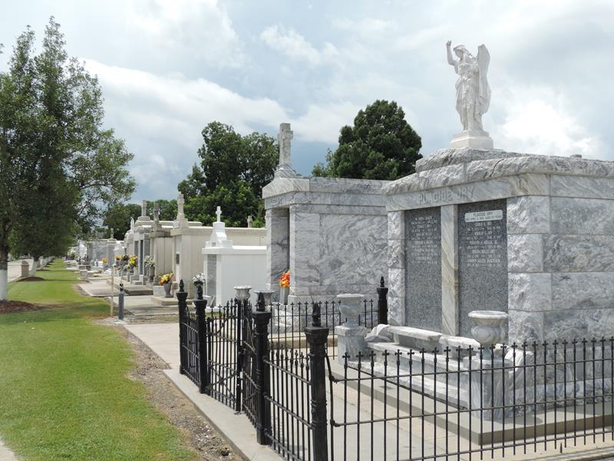

Evelyn Montz Graugnard on Monday, March 24, 2008 at 9:30 p.m.
Beloved wife of Leon (Cat) Graugnard. Mother and mother-in-law of Gordon and Mary Guidry, Jon and Lorraine Guidry and Rebecca and Peter Roccaforte, Jr. Also survived by 10 grandchildren, 23 great-grandchildren and 2 great-great-grandchildren. Sister of Ruth Levet, Za and Ruffin Montz, the late Florence Vicknair, Ruby Roussel, Helmuth Sr., Henry Sr. and Eddie Montz. Age 85 years. A native of and resident of Reserve, LA.
Religious services at St. Peter Catholic Church, Reserve, LA, Thursday, March 27, 2008 with burial in St. Peter Cemetery.

The Times-Picayune, New Orleans, Louisiana
26 Mar 2008

