Joyce Theresa (Williams) Graugnard
June 18, 1927 – March 5, 2024

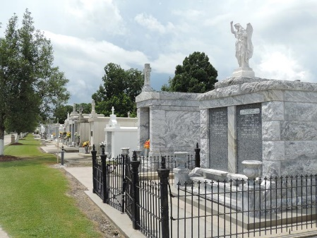
Joyce Graugnard, 96, of Reserve, Louisiana, passed away on March 5, 2024, after a long and healthy life and a very brief illness.
Joyce Theresa Williams was born in Lions, Louisiana on June 18, 1927, to parents John and Virginia Williams. She was part of two families, the first with five children, and the second, where she was one of nine siblings. Joyce graduated from Leon Godchaux high school in 1945. She went on to work at Altman’s department store until meeting her future husband, Fernand, who happened to be the brother of her best friend and future sister-in-law, Regina.
Fernand and Joyce were married on September 23, 1950 in Reserve. They went on to have five children, Joyce, Emile, Fernand, Carolyn, and Virginia. They raised their family in Lions, on the Graugnard property abutting the Terra Haute plantation. Joyce retired from outside work to care for her husband, which turned out to be a common theme for the rest of her life. Always the caretaker, she looked after her parents, siblings, nieces and nephews, up through the final days of her last living sibling, Ethyl Mae.
Joyce has been an active member of St. Peter’s Parish and a member of the Ladies’ Altar Society. Her Catholic faith was paramount in her life, providing her comfort in her journey through to her last days.
Joyce was an avid gardener and active participant at the St. John’s Parish Senior Center. A weed never survived in a garden she passed by! Her most cherished activity was coming to visit her grandchildren in Louisiana and Texas. One of her proudest accomplishments was getting her driver’s license in 1973; an unintended consequence of helping her sister attempt to learn to drive.
Joyce was ready, as she put it, “to act foolish”, and loved her family gatherings. All of us will remember Joyce for her generosity and willingness to care for family and friends, including the use of those driving skills to help out. She led a simple life; her priorities focused on being a loving part of our lives. Each of us has a story of Joyce’s birthday and anniversary cards, jumping in to babysit, teaching one how to make a roux, or moral support when needed.
Joyce was preceded in death by her husband, Fernand, her daughter, Virginia, great-grandchildren, Hunter and Peyton, and her best friend Helen Kliebert, who just recently passed. She is survived by her daughters Carolyn (Steve Waken), Joyce (Ralph Ruiz), sons Fernand (Patricia) and Emile (Sharon), and son-in-law Arthur Virgadamo (Virginia). Joyce was also the proud grandmother of eight, with sixteen wonderful great-grandchildren. Those of us who are not blood-related consider her to be our mother, aunt, and friend.
Funeral mass will be held at 11:00 a.m, at St Peter’s Catholic Church, 1550 Highway 44, Reserve, Louisiana; viewing will be available beginning at 9:00 a.m. In lieu of flowers, the family requests donations be made to St Peter Catholic School, at 188 W. 7th St, Reserve, LA, 70084, or at the school’s web site www.stpeterreserve.org.
Millet-Guidry Funeral Home, LaPlace, Louisiana

