Leon G. Graugnard
September 15, 1927 – April 25, 2021

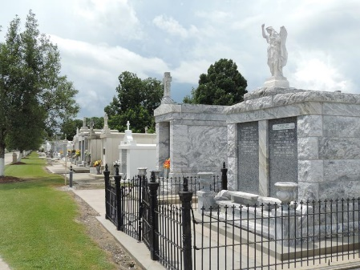
Leon “Cat” Graugnard, a native of Lions and a resident of Reserve, passed away on Sunday, April 25, 2021 at the age of 93.
Leon was a veteran of the U.S. Army & Merchant Marines who proudly served our country in the 1950’s.
Leon “Cat” took pride in the beautification of his flower bed, planting trees and shrubs, and landscaping the yard. A John Deere Tractor was a must have to cut his grass. He cherished numerous special moments while routinely visiting with family on the porch in the afternoons. Cat loved talking about his vehicles. They were always spotless. He washed them on Saturday mornings as he enjoyed riding in a clean vehicle. He was a generous, loving, kind gentleman. He definitely was a “work hard” kind of guy.
He is survived by stepchildren, Rebecca Roccaforte (Peter), Gordon Guidry (Mary), and Jon Guidry (late Lorraine Guidry); step-grandchildren, Robin Franks, Scott Guidry, Ginger Guidry, Tiffany Guidry, Halaine DeWerff, Troy Guidry, Chad Guidry, Toby Guidry, Rhonda Roccaforte, and Roxanne Campbell. Leon is also survived by a sister, Jeanne Tregre (late Bruce Tregre); and a sister-in-law, Joyce Graugnard.
He is preceded in death by his wife Evelyn Montz Graugnard; parents, Azelie and Emile Graugnard; brother, Fernand Graugnard; sisters, Azelie Granier (John), Marie Louise Martinez (Charles), Regina Graugnard, and Emilie Brocato (Frank).
A visitation will be held on Wednesday, April 28, 2021 at St. Peters Catholic Church in Reserve, LA from 9:30 AM to 11:00 AM. A Mass of Christian Burial will begin at 11:00 AM. Interment will follow in the church cemetery.
Rose Lynn Funeral Home, Lutcher, Louisiana

