Obrice Robert Graves Sr.
April 16, 1966 – November 4, 2007
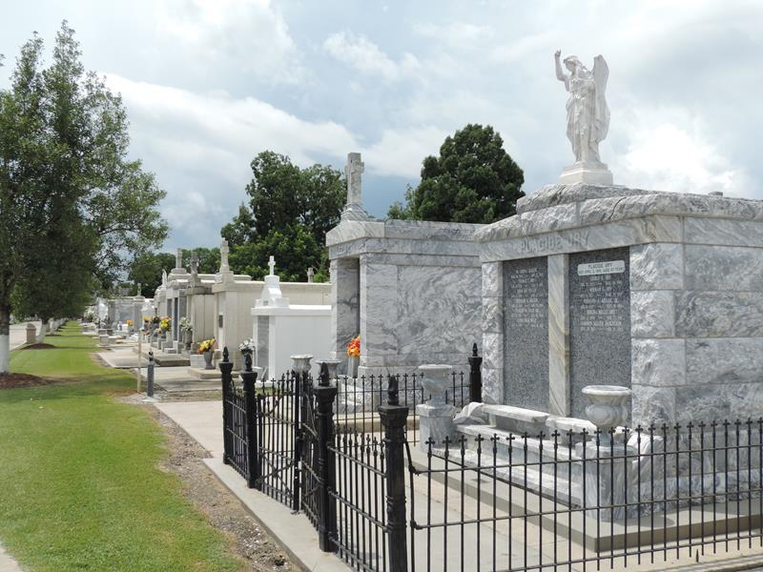

Obrice Robert Graves Sr. - A native and resident of New Orleans, he died at 7:10 a.m. Sunday, Nov. 4, 2007, at Canon Hospice in Jefferson. He was 41.
Visiting at William Ross United Methodist Church, 7510 Pearl St., New Orleans, on Saturday, Nov. 10, from 9:30 a.m. until religious service at 11 a.m. Entombment in St. Peter's Catholic Church Mausoleum, Reserve.
He is survived by his parents, Robert Graves Sr. and Carolyn Branch Graves; three sons, Obrice Jr., Brandan and Obrice Graves III; two sisters and a brother-in-law, Quentialla Graves and Opal Alice and Kim Garner; a brother and sister-in-law, Orville and Taletha Graves; stepbrother, Gregory Landry; companion, Elanda Landa; aunts, uncles, nieces, nephews, cousins, other relatives and friends.
Arrangements by Brazier-Watson Funeral Home, Donaldsonville.
The Advocate, Baton Rouge, Louisiana
November 9, 2007

