Leroy Rosemond Gravois

October 6, 1937 – May 26, 2021

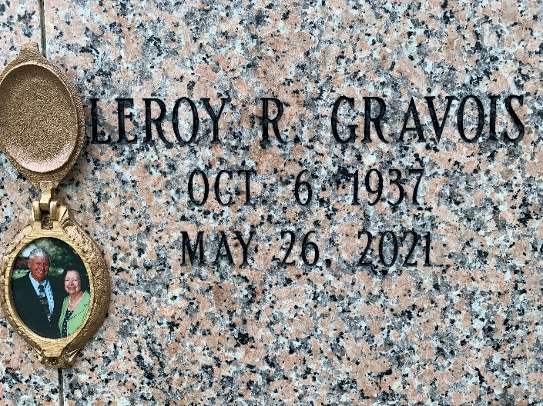

Photo by Team T-Lo

Leroy R. Gravois passed away on Wednesday, May 26, 2021 at the age of 83. He was born in Vacherie, LA and was a resident of LaPlace, LA.

Beloved husband for 63 years of Patricia Matherne Gravois. Loving father of Kimberly Gravois Larson (Richard) and Michael Paul Gravois (Amy). Grandfather of John, Mark, and Mary Larson and Hunter and Hannah Gravois. Son of the late Lizzie Webre Gravois and Lynn Gravois, Sr. Brother of Richard Gravois (Laura), Randy Gravois (Bonnie), Ronald Gravois, Lynn Gravois, Jr. (Sue) and the late Larry Gravois, Marie Gravois, Roland Gravois, Elizabeth Martinez (Jerrel) and Martin Gravois (Christina). Also survived by many nieces and nephews.

Relatives and friends are invited to attend the Visitation and Memorial Mass at St. Joan of Arc Catholic Church, 529 W. 5th Street, LaPlace on Friday, June 4, 2021. Visitation at the church from 10:00 a.m. to 12:00 p.m. followed by a Memorial Mass at 12:00 p.m. Inurnment in St. Peter Cemetery.

Millet-Guidry Funeral Home, LaPlace, Louisiana

May 28, 2021