Christine Gray
About 1960 – March 4, 2019

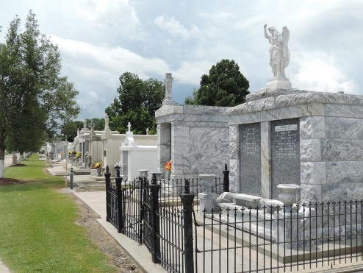

Christine Marie Gray "Chris" on Monday, March 4, 2019 at her sister's home in LaPlace, LA.
Daughter of the late Mildred Nicholson and Joseph Gray, Jr. Mother of Richard Davis, Tiffany Johnson (Jernone) and Brandi Jack. Sister of Kenny Gray, Joseph Darran Gray, Kelly Nellum (Elbert), Brian Davis and Victor Schexnayder (Vanessa). Also survived by 5 grandchildren and a host of aunts, uncles, nieces, nephews, cousins, other relatives and friends. Age 59 years. A native and a resident of Reserve, LA.
Relatives and friends of the family, also priest and parishioners of Our Lady of Grace Catholic Church and all neighboring churches are invited to attend the Funeral Mass at Our Lady of Grace Catholic Church, 772 Hwy 44 (River Road), Reserve, LA on Saturday, March 16, 2019 at 10:00 AM. Father Christopher Amadi, Celebrant. Interment St. Peter Cemetery, Reserve, LA. Visitation at the above named church from 8:15 AM until Mass time. SERVICED BY ROBOTTOM.
The Times Picayune, New Orleans, Louisiana
March 13-15, 2019

