Demario Lavell Gray
About 1954 – December 13, 2015

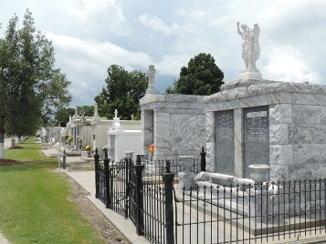

Demario Lavell Gray, age 29, departed this life on Sunday December 13, 2015.
He was the son of Dawn Gray and Solomon Joseph, husband of Readyieka Stewart, father of Zakia and DeMyjarnae Stewart. Also survived by a host of other relatives and friends.
Funeral will be held Saturday, December 26, 2015, at 11:00 am at Beech Grove B.C., Reserve, La., Rev. Wesley Anderson Sr., Pastor Hosting, Rev. Carla Ceaser Officiating. Interment in St. Peter Catholic Cemetery, Reserve La. Visitation at church beginning at 10 am until services time.
Service Entrusted to Hobson Brown Funeral Home, Garyville, La. 70051, (985) 535-2516.
The New Orleans Advocate, Louisiana
December 24-26, 2015
**

One of the two men wounded by gunfire over the weekend in Reserve has died, making for the sixth homicide of the year in the St. John the Baptist Parish, the Sheriff's Office said Monday (Dec. 14). Deputies identified the dead man as Demario Gray, 29, of Reserve.
Gray died Sunday. Deputies said they did not know the condition of the second victim, a 30-year-old Reserve man.

NOLA.com
December 14, 2015

