Joseph Gray Jr.

January 7, 1931 – September 25, 2014

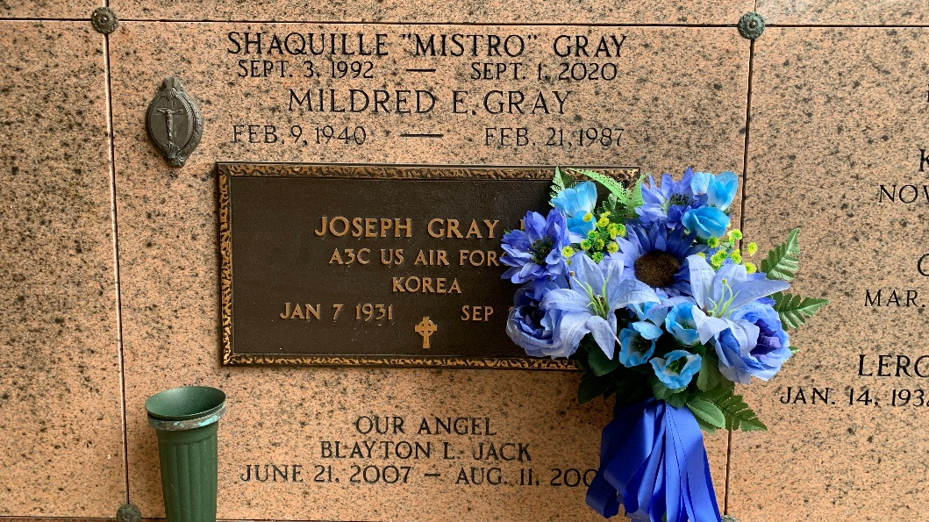

Photo by Team T-Lo

JOSEPH GRAY, JR. on Thursday, September 25, 2014 at his daughter's home in LaPlace, LA.

Son of the late Lillie Jackson and Joseph Gray, Sr. Husband of the late Mildred E. Nicholson Gray. Father of Christine Gray, Kenny Lee Gray, Joseph D. Gray, Brian Davis and Kelly Gray Nellum. Brother of the late Melvina T. Ursin, Betty G. Gray, Melva G. Smith and Melvin Herman Ursin, II. Also survived by 11 grandchildren, 11 great grandchildren and a host of nieces, nephews, cousins, other relatives and friends. Age 82 years. A native and resident of Reserve, LA.

Relative and friends of the family, also priest and parishioners of Our Lady of Grace Catholic Church and all neighboring churches are invited to attend the Funeral Mass at Our Lady of Grace Catholic Church, 772 Hwy 44 (River Road), Reserve, LA on Saturday, October 4, 2014 at 10:00 AM. Father Christopher Amadi, Celebrant. Interment St. Peter Cemetery, Reserve, LA. Visitation at the above named church from 8:15 AM until Mass time. Rosary at 9:15 AM. SERVICED BY ROBOTTOM.

The Times-Picayune, New Orleans, Louisiana

September 29 – October 3, 2014