Royal Gray Jr.

June 21, 1953 – April 1, 2020

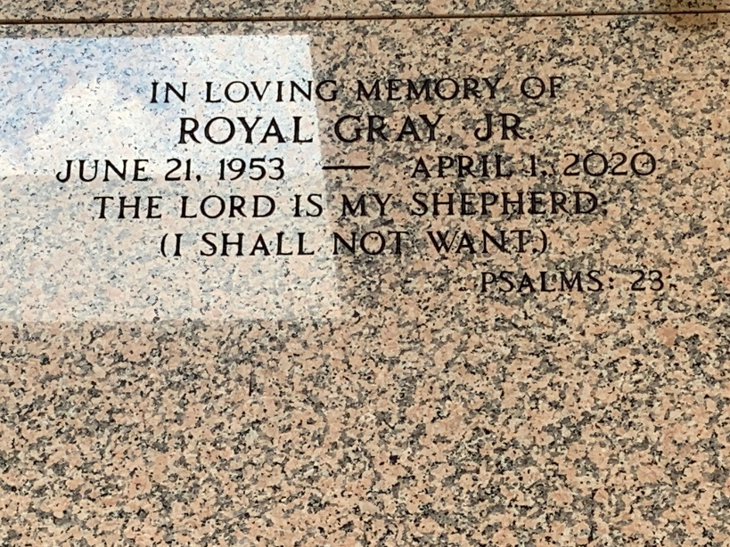

Photo by Team T-Lo

Royal Gray, Jr., age 66, was called to his Heavenly home on Wednesday, April 1, 2020. Royal retired from St. John the Baptist Parish Government Water Works Department.

Graveside service on Wednesday, April 8, 2020, at St. Peters Cemetery, Reserve, LA. Father Christopher Amadi, SSJ Celebrant.

He was preceded in death by his father, Royal Gray Sr.; grandson, Royal Gray IV; mother-in-law, Mavis P. Fobb and brother-in-law, Rudy Sylvain.

He leaves to cherish his memories his wife, Monica P. Gray; 4 sons, Royal III, Koyal, Tomako and Damien Gray; mother, Mamie Gray; 4 siblings, Doris and Shirley Ann Gray, Audrey G. Sylvain and Andrea Cambre; 5 grand-children, Koyal Jr, Tomako Jr, Roel, Jeremiah and Daniel Gray; father-in-law, Roy Fobb; daughter-in-law, Tiyanica Gray; 12 brothers & sisters-in-law, Raynell, Elroy (Linda) and Kenneth (Yvette) Perrilloux, Claudette P. Edwards, Gaynell (Eric) Gauff, Sherman, Dorlisa and Rico (Teneka) Fobb, Aisha (Rondell) Mealey, Kerry (Wanda) and Michael (Fontella) Baker and Cheryl (Timothy) Nicholson and a host of nieces, nephews, aunts, uncles, other relatives and friends. Services Entrusted to the Caring Staff of: Professional Funeral Services, Inc. "Celebrating Life" 1449 N. Claiborne Avenue, New Orleans, LA. 70116. 504-948-7447.

The Times-Picayune, New Orleans, Louisiana

April 6-8, 2020