Shaquille Gray

September 3, 1992 – September 1, 2020

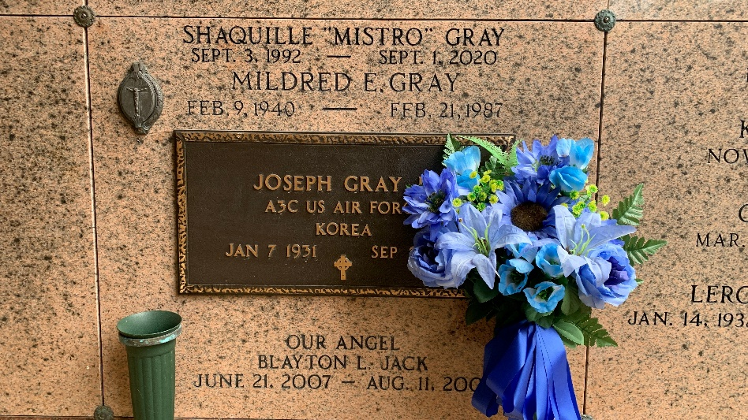

Photo by Team T-Lo

Shaquille "Mistro" Gray, age 27, of Reserve, LA, transitioned from his earthly life on Tuesday, September 1, 2020, Beloved son of Kelly Ann Gray, of Laplace, LA and Michael Foley, of Marrero, LA. Shaquille was born September 3, 1992 in Marrero, LA. Loving brother of Se-Darius Gray, of Laplace, LA and Michael Foley, Jr., of Marrero, LA. Also survived by a host of aunts, uncles, cousins, and other relatives and friends. A native and resident of Reserve, La. Shaquille was preceded in death by his Grandfather, Joseph Gray, Jr.; Grandmother, Mildred Eve Gray; and aunt/godmother, Christine Marie Gray. Pastor, Officers, and members of New Wine Christian Fellowship of Laplace, La and all neighboring churches are invited to attend the homegoing celebration, Saturday, September 12, 2020 at 11:00 a.m. at New Wine Christian Fellowship, 3353, 1929 West Airline Hwy, Laplace, La 70068. Pastor Neil Bernard officiating. Viewing will be held from 9:00 a.m. until service time. Visitation will also be held Friday, September 11, 2020 at Bardell's Mortuary, 3856 Hwy 44, Mt. Airy, LA from 3 p.m. until 5 p.m. Masks must be worn and social distancing must be practiced. Services entrusted to Bardell's Mortuary. Information: (985) 535-6837.

The Times-Picayune, New Orleans, Louisiana

September 10-12, 2020

\*\*

The state Department of Corrections has identified the Louisiana State Penitentiary inmate who died Tuesday following a fight at the Angola dorms.

DOC spokesman Ken Pastorick said Shaquille Gray, 27, died after a fight with Kenny Veal, 32, that occurred around 9:30 a.m. Tuesday in one of the Main Prison dormitories, large rooms that house dozens of inmates sleeping on bunk beds.

Gray was convicted in Orleans Parish in 2015 on armed robbery and was serving a 10-year sentence.

Veal was serving a life sentence for second-degree murder and a 10-year sentence for aggravated battery running consecutive to the life sentence. He was convicted in Terrebonne Parish in 2018 on both crimes.  Veal had previously accrued good time parole supervision for previous convictions of simple robbery and possession of a firearm by a convicted felon, but had it revoked after his 2018 convictions.  He has been incarcerated at Angola since October 2018. It is unclear if Veal was injured in the fight or if he will face criminal charges.

Pastorick said correctional officers making routine rounds discovered the fight on Tuesday.

DOC is conducting a joint investigation with the West Feliciana Parish Sheriff's Office, which would be responsible for filing criminal charges.

<snip>

The Advocate, Baton Rouge, Louisiana

September 3, 2020