Sonja P. (Fernandez) Gray

September 15, 1917 – December 22, 2017

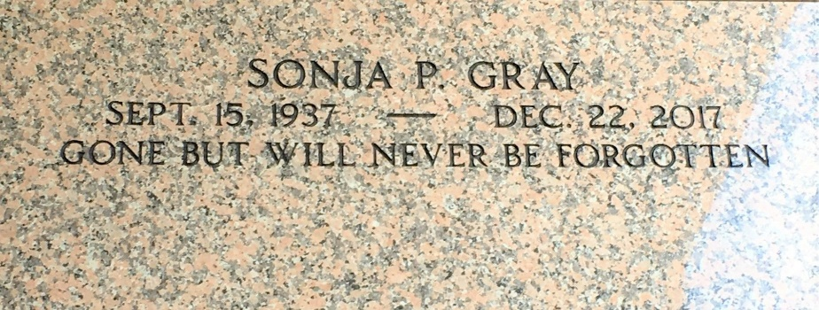

Photo by Team T-Lo

Sonja Gray, age 80, departed this life on Friday, December 22, 2017.

Daughter of the late Vasco Pina and Clarinda (Gail) Fernandez, and she was reard by Earl Brown, Wife of the late Albert ""Kojo"" Gray, Sr, Mother of Albert J. Gray Jr., Romona F. Edwards, Elvera M. Riley, Domingo Gray and the late Darryl Gray. Sister of Myrna, Tracy, Stacy, Darlene, Earl, and Willie Brown, also the late Laverne Green. Sonja is also survived by daughters and sons in laws, sister in law, brother in law, 12 grandchildren, 19 great grandchildren, nieces, nephews, Krewe of Agape other relatives and friends.

Relatives, friends, officers and members of Our Lady of Grace Catholic church are invited to the Celebration of Life Service on Friday, December 29, 2017 at 10:00am at the above name church 772 HWY 44 Reserve, La father Amadi officiating. Visitation will be held from 8:15am until the hour of service. Services entrusted to the caring staff of Hobson Brown Funeral Home, Garyville, La (985) 535-2516.

The New Orleans Advocate, Louisiana

December 27-29, 2017