Allene (Meekins) Gregoire
April 2, 1927 – May 17, 2010

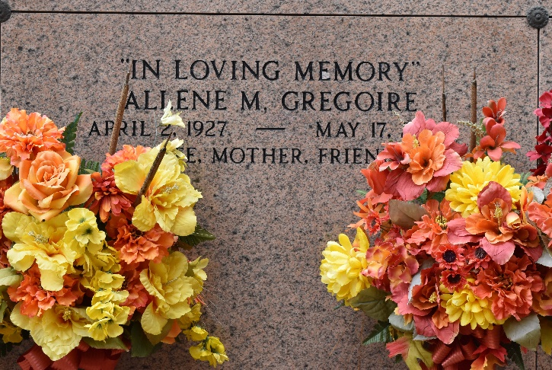

Allene Meekins Gregoire on Monday, May 17, 2010 at The Carpenter House, Baton Rouge, Louisiana.
Daughter the late Robert J. and Nellie Johnson Meekins. Wife of the late Charles A. Gregoire. Mother of Darryl Charles Gregoire and Crystal Gregoire King. Sister of Bobbie McLemore of Detroit, Michigan, Nellie Shields of Flint, Michigan, Gladys Meekins of Pine Bluff, Arkansas, Martha Meekins of Euclid, Ohio, the late Brady, T'Arthur, Charlie, Leo, Cleo, Eugene (her twin brother), Robbie and Acie Meekins. Grandmother of DaRonne Davis of Los Angeles, California and Shelby Taylor King of Baton Rouge, Louisiana. Great grand-mother of Layla Davis of Los Angeles, California. Also survived by four Godchildren, Pamela Joseph, Erica Nicholas Cola, Naysha Bourgeois and D'Artagnan Forest, four devoted friends, Carrie Forest, Lois Gray, Beverly Harris and Elexia Henderson, and a host of nieces, nephews, great nieces and nephews, cousins, other relatives and friends.
Relatives and friends of the family, also pastors, officers and members of Providence Baptist Church and all neighboring churches and employees of St John Parish School System and Prudential Gardner Realtors of LaPlace, LA are invited to attend the funeral at Providence Baptist Church, 240 Pine Street, LaPlace, LA, on Friday, May 21, 2010 at 11:00 AM. Rev Willie Smith, Pastor, Officiating. Interment St Peter Cemetery, Reserve, LA. Visitation at the above named church from 10:00 AM until service time. SERVICED BY ROBOTTOM.

The Times-Picayune, New Orleans, Louisiana
May 20, 2010

