Audrey Marie (Cook) Gregoire
April 16, 1936 – July 9, 2016

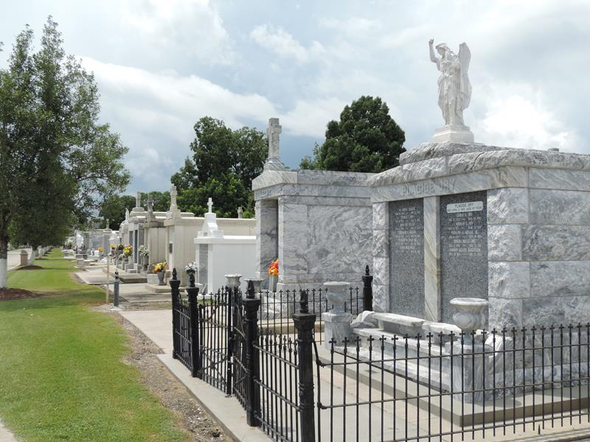

Audrey Gregoire on Saturday, July 9, 2016 at Twin Oaks Nursing Home, LaPlace, LA. Daughter of the late Stella Placide and Henry H. Cook. Wife of the late Joseph T. Gregoire. Mother of Rhonda G. Lemons, Pauline G. Pierre (Jimmy), Ursula G. Joseph (Latherio), Lentreise G. Bardell (Christopher), Doriat G. Ambrose (Gerome), Kem Gregoire, Aaron Gregoire and the late Reynaldo "Ray" Gregoire. Sister of Larry Cook, Sr., Ollie "Macy" Anderson, David A. Cook and the late Stella "Jean" Edwards. Also survived by 11 grandchildren, 10 great grandchildren and a host of nieces, nephews, cousins, other relatives and friends. Age 80 years. A native and resident of Reserve, LA.
Relative and friends of the family, also priest and parishioners of Our Lady of Grace Catholic Church and all neighboring churches are invited to attend the Funeral Mass at Our Lady of Grace Catholic Church, 772 Hwy 44 (River Road), Reserve, LA on Saturday, July 16, 2016 at 10:00 AM Father Christopher Amadi, SSJ, Celebrant. Interment St Peter Cemetery, Reserve, LA. Visitation at the above named church from 8:15 AM until Mass time. Rosary at 9:15 AM. SERVICED BY ROBOTTOM

The Times-Picayune, New Orleans, Louisiana
Jul. 12 to Jul. 15, 2016

