Charles Anthony Gregoire
December 8, 1929 – July 19, 2008

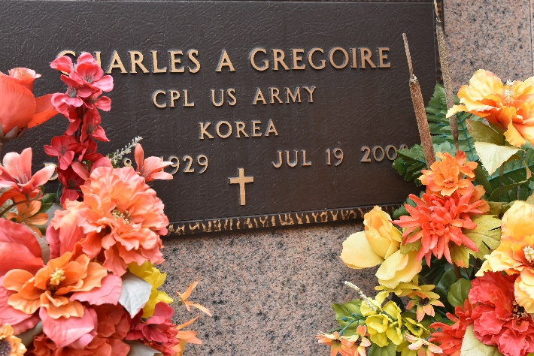

Charles Anthony Gregoire "Charley" departed this earthly home to enter his heavenly home on Saturday, July 19, 2008.
Son of the late Kalsaw and Gertie Himes. Beloved and devoted husband of Allene Meekins Gregoire. Loving and dedicated father of Darryl C. Gregoire of Reserve, LA and Crystal G. King of Baton Rouge, LA. Brother of Oneda Joseph, Geneva Stemley both of La Place, LA, the late Nelson and Joseph Gregoire and Vera Bell. Also survived by two grandchildren, Da Ronne Davis of Los Angeles, CA and Shelby Taylor King of Baton Rouge, LA and one great grandchild, Layla Davis of Los Angeles, CA. Brother-in-Law of Charles Stemley, Sr., and Audrey Gregoire both of La Place, LA, Bobbie Mc Lenmore of Detroit, MI, Nellie Sheilds of Flint, MI, Acie and Gladys Meekins of Pine Bluff, AR and Martha Meekins of Euclid, OH and the late Clinton Joseph, Willie Bell and Victoria Gregoire. Godfather of Pamela Joseph of Marrero, LA, Erica Nicholas Cola of Gramercy, LA, D'Artaganan Forest of Houston, TX and Aaron Gray of Baton Rouge, LA. Also survived by a host of nieces, nephews, other relatives and friends. A native of St. James, LA and a resident of La Place and Reserve, LA for many years. Mr. Charles Anthony Gregoire was a Veteran of the U. S. Army.
Relatives and friends of the family, also priest and parishioners of Our Lady of Grace Catholic Church, members of Providence Baptist Church #1 of La Place, LA and all neighboring churches, employees of Nalco, Dow Chemical (Belle Rose Plant), Prudential Gardener Realtors and St. John the Baptist Public School System and members of the Knights of Peter Claver Council #73 and member of the Ambassadors Social and Pleasure Club are invited to attended the Mass of Christian Burial from Our Lady of Grace Catholic Church, 772 Highway 44, Reserve, La., on Thursday, July 24, 2008 at 11:00 A.M. Father Joseph Rodney, S.S.J., Pastor - Celebrant. Interment St. Peter's Cemetery Reserve, LA. Visitation at the above named church on Thursday from 9:00 A.M. until Mass time. Recitation the Rosary at 10:00 A.M. SERVICED BY ROBOTTOM.

The Times-Picayune, New Orleans, Louisiana
July 23, 2008

