Lloyd J. Gregoire
January 21, 1913 – June 29, 1963

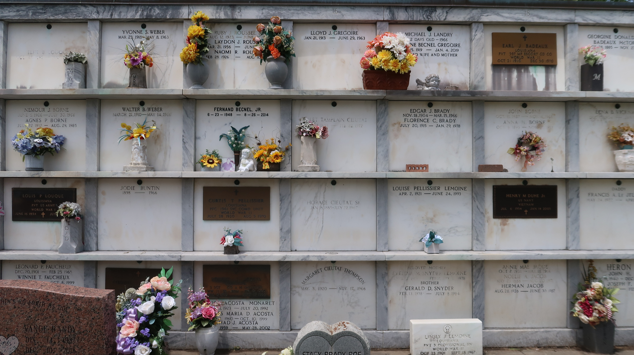

Louisiana, U.S., Statewide Death Index, 1819-1964

Name Lloyd J Gregoire
Age 50
Birth Year abt 1913
Death Date 29 Jun 1963
Death Place Orleans, Louisiana, USA
**

U.S., World War II Draft Cards Young Men, 1940-1947

Name Lloyd Joseph Gregoire
Race White
Age 27
Birth Date 21 Jan 1913
Birth Place Ascension, Louisiana
Residence Place Garyville, St. John, Louisiana
Registration Date 16 Oct 1940
Registration Place Reserve, St. John, Louisiana
Employer Godchaux Sugar Refinery
Height 5ft. 3in
Weight 115
Complexion Light
Hair Color Brown
Eye Color Brown
Next of Kin Mrs Eusebe Valery Landry

